
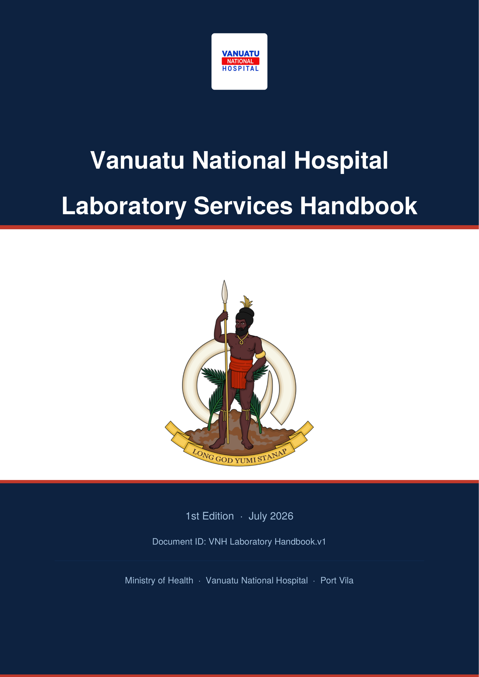

Preface
This is the Laboratory Services Handbook of the Vanuatu National Hospital (VNH) Department of Laboratory Services.

Document Control
Document ID: VNH Laboratory Handbook.v1.docx
Author | Mr. SERO Kalkie (MLT, VNH Laboratory)
Contributors | Dr. TARINAVANUE-GARAE Crystal (Pathologist)  Mr. PAKOA George (VNH Allied Manager)  Mr. TOM Daniel Robert (Dip. MLS)  Mr. SEULE Raymond (Dip. MLS)  Mr. KALMOR Jeffery (BMLS)  Miss. DICK Leiwia (BMLS)  Miss. TOANGWERA Lucienne (BMLS)  Mrs. SEWEN Susan (BMLS)  Mr. BAKON Samuel (BMLS)  Mrs. TOSUL Mary Ann (BMLS)  Dr. LOWES Hannah
Verified by | Mr. TOSUL Peter, Principal Laboratory Officer
Authorized by | Dr. TARINAVANUE-GARAE Crystal, Pathologist
Issue date | July 2026
Version date | July 2026
Next review date | July 2027

Do not use this handbook beyond its next review date. The Vanuatu National Hospital Laboratory Department reserves the right to amend, omit, or add to the procedures in this handbook at its discretion.

How to Use This Handbook
This handbook gives pre-analytical and post-analytical information and guidance to laboratory service users when requesting tests available at the VNH Laboratory Department, including:
- Laboratory contact details and opening hours
- Instructions for completing sample and request form information
- Details of services provided, including a current test directory
- Handling and transporting samples to the laboratory
- Point-of-care testing
- Specimen collection procedures and specific sample requirements
It is intended for use by clinicians, nurses, and other VNH staff who request, collect, or handle laboratory specimens.

Handbook Updates
The VNH Laboratory Department intends to update this handbook on a regular basis. Comments, suggestions, and corrections are encouraged and should be directed to the relevant Departmental Officer in Charge, the Principal Laboratory Officer's Office, and/or the VNH Pathologist.

Contents
Preface 1
1.1. Document Control 1
1.2. How to Use This Handbook 1
1.3. Handbook Updates 2
Contents 3
2. Introduction 8
2.1. Laboratory Team 8
2.2. Mission Statement 8
2.3. Objectives of the Laboratory Services 8
3. Laboratory Department Contact Details 10
3.1. Laboratory Advisory Service 10
4. Quality System 12
4.1. Internal quality control 12
4.2. External quality control 12
5. Operating Hours 13
6. Requesting Tests 14
6.1. How to request a sample 14
Routine and Urgent Requests 14
a) Complete the request form fully 14
b) Flag urgent requests clearly 14
c) Use the correct container for the test 14
d) Send the specimen promptly 14
Verbal (e.g. telephone) add-on requests 14
Out-of-hours requests 14
6.2. Authorized entry and signatories 15
7. Specimen Criteria 16
7.1. Minimum acceptance criteria 16
7.2. Common rejection reasons 16
Important notes for requesters 16
8. Specimen Collection Guidelines 17
8.1. Request form information 17
8.2. Labelling specimens 17
8.3. Quick Reference — Sample Types & Containers 17
9. Specimen Collection Procedures 19
9.1. Venipuncture 19
General Procedure: 19
Venipuncture using a vacutainer: 19
Venipuncture using a syringe: 20
Venipuncture in infants/children: 20
Specialised blood sample: Neonatal bilirubin samples 20
9.2. Blood culture collection 21
Procedure: 21
9.3. Stool collection 21
Notes for clinicians 21
Procedure: 21
Specialised stool sample: Acute Flaccid Paralysis (AFP) sample for polio investigation 22
9.4. Urine collection 22
Procedure: 22
Specialised urine sample: Urine for Cytology 23
9.5. Sputum collection 23
Specialised sputum sample: Mycobacterium tuberculosis investigation 23
Procedure: Gastric wash 23
9.6. Semen collection 24
Note for clinicians 24
Procedure: 24
9.7. Nasopharyngeal swab collection 24
Note for clinicians 25
Procedure: 25
9.8. Oropharyngeal swab collection 25
Note for clinicians 25
Procedure: 25
9.9. Culture swab collection (all general bacteriology) 26
Procedure: 26
9.10. Cerebrospinal fluid (CSF) collection 26
Procedure: 26
9.11. Other sterile body fluids collection 27
Procedure: 27
9.12. Smear collection 27
Procedure: 27
Specialised smear sample: Pap smear (cervical smear) 28
Procedure: 28
9.13. Fine Needle Aspiration (FNA) 28
Procedure: 28
9.14. Tissue Biopsy collection 29
Note for clinicians 29
Procedure: 29
10. Handling and Transportation of Specimens to VNH Laboratory 31
10.1. Biohazard carrier bag 31
10.2. Specimen delivery 31
11. Customer feedback and complaints 32
12. Departmental Services 33
13. Haematology Services 34
13.1. Test Directory 34
13.2. Critical values (phoned to requesting clinician once verified): 35
13.3. Delivery of test results 35
14. Blood Bank / Transfusion Services 36
14.1. Special requirements for sample collection 36
14.2. Test Directory 36
14.3. Clinical use of blood 36
14.4. Setting up and monitoring an infusion 37
14.5. Available blood products 37
14.6. Risks of Transfusion 37
14.7. Red Cell Transfusion 38
14.8. Plasma Transfusion 38
14.9. Blood Safety 38
14.10. Blood Group Compatibility 38
14.11. BLOOD DONATION 39
14.12. Donor Acceptance Criteria 39
14.13. Blood Unit Acceptance 40
14.14. Reasons for Deferral 41
14.15. BLOOD TRANSFUSION – when a new sample is required 41
14.16. Delivery of test blood results 41
15. Serology Services 42
15.1. Test Directory 42
15.2. Delivery of test results 43
16. Biochemistry Services 44
16.1. Test Directory 44
16.2. Critical values (phoned to requesting clinician once verified): 45
16.3. Delivery of test results 46
17. Microbiology Services 47
17.1. Test Directory 47
17.2. Delivery of test results 48
18. Tuberculosis (TB) Services 49
18.1. Test Directory 49
18.2. Delivery of test results 49
19. Molecular Laboratory 50
19.1. Test Directory 50
19.2. Delivery of test results 50
20. Histology Services 51
20.1. Test Directory 51
20.2. Delivery of test results 51
21. Cytology Services 52
21.1. Test Directory 52
21.2. Delivery of test results 53
22. Other / Specialist Referred Tests 54
23. Laboratory-Based Surveillance 55
23.1. Core syndromes 55
23.2. Vaccine-preventable disease (VPD) / hospital-based active surveillance (HBAS) 56
23.3. Alert thresholds for action 58
24. Specimen Referral 60
24.1. From outer islands (by air) 60
24.2. Packaging of specimens 60
Primary receptacle (tube, vial, bottle) 60
Secondary packaging 60
Outer packaging 60
24.3. Send-away (overseas) testing 61
25. Laboratory results and reports 62
26. Laboratory Consumables 63
Annexure 1 — Transfusion Adverse Reactions 64
Acute reactions (during or within 24 hours of transfusion) 64
Category 1: Mild 64
Category 2: Moderately severe 64
Category 3: Life-threatening 64
Delayed complications 64
Annexure 2 – Laboratory Request Form 65
Annexure 3 – Crossmatch request form 66
Annexure 4 – TB Request Form 67
Annexure 5 – Laboratory Surveillance Form 68
Annexure 6 – Laboratory consumable order form 69
Annexure 7 – Laboratory complaint & compliment form 70

Introduction
The Laboratory Department is part of the Vanuatu National Hospital (VNH). Its staff aim to provide a quality-assured and accessible service to VNH laboratory users, to promote the well-being of the people of Vanuatu. The VNH Laboratory comprises the following departments:

- Phlebotomy
- Haematology
- Serology
- Biochemistry
- Molecular
- Blood Bank and Transfusion
- Microbiology
- Tuberculosis (TB)
- Histology
- Cytology
- Inventory / Stores
- Reception

Laboratory Team
Approximately 80% of laboratory staff are formally qualified, holding a Bachelor or Diploma in Medical Laboratory Science. The remainder are on-the-job trained staff with several years of experience.
The Principal Laboratory Officer (PLO) is the most senior position and is responsible for managing the Laboratory Department and overseeing all staff activities. A Quality Officer and Operational Supervisor are responsible for quality control, equipment calibration, and maintenance, and on a routine basis also perform the same duties as other medical laboratory officers. An Officer In-Charge leads each laboratory section and, likewise, performs routine testing duties as well as managing their section. A Laboratory Health and Safety Officer oversees laboratory safety.
A medical Pathologist also attends to the services of the Laboratory Department.

Mission Statement
The laboratory section’s mission statement was produced in conformity with the Ministry of Health and National Medical Laboratory as to provide a quality assured laboratory service, which supports the delivery of health services at all levels of care prevention, diagnosis, management and surveillance of the Vanuatu’s burden of diseases in both urban and rural areas.
Our vision is “To have an integrated and decentralized health system that promotes an effective, efficient and equitable health service for the good health and general wellbeing of all people in Vanuatu.”

Objectives of the Laboratory Services
- Ensure accuracy of test results.
- Ensure all test results are released to clinicians on time.
- Ensure availability of safe blood and blood products.
- Ensure the requirements and expectations of our customers are satisfied.
- Provide staff with opportunities for professional development and encourage involvement in decision-making.
- Provide ongoing laboratory support to both horizontal and vertical National Health Programs.
- Provide the knowledge, competencies, and skills to support packages of care and maintain professionalism among laboratory personnel.
- Establish appropriate, standardized laboratory designs and infrastructure for each level of care.
- Provide standard packages of laboratory tests at each level of the Vanuatu health system, and promote their rational use for prevention, diagnosis, treatment management, and surveillance.
- Establish and maintain a quality management system to ensure quality laboratory services.
- Promote and strengthen research and development.
- Work towards ISO certification by 2030.

Laboratory Department Contact Details
Address: Laboratory Department, Vanuatu National Hospital, PMB 9013, Port Vila
Switchboard: +678 22100
Laboratory Section | Contact | Officer In-Charge
Reception & Phlebotomy | Ext 1954 (VOIP) | Mr. ESCAR Avock (A/Officer in charge)
Haematology | Ext 1949 (VOIP) | Mr. TOM Daniel Robert
Biochemistry | Ext 1949 (VOIP) | Mr. Samuel Bakon
Blood Bank Counselling room | Ext 1968 (VOIP) | Mr. BULEMARU Ray
Serology and Molecular | Ext 1950 (VOIP) | Mr. KALOMOR Jeffery
Microbiology | Ext 1950 (VOIP) | Mrs. TOSUL Mary-Ann
Tuberculosis (TB) | Ext 1949 / 1950 (VOIP) | Mr. SEULE Raymond
Histology | Ext 1949 (VOIP) | Mr. SERO Kalkie (A/Officer in charge)
Cytology | Ext 1949(VOIP) | Miss. TOANGWERA Lucienne
Inventory / Store | Ext 1949 / 1950 (VOIP) | Miss. GAVIGA Justina
Blood Bank & Blood Transfusion | Ext 1950 (VOIP) | Mr. BULEMARU Ray (A/Officer in charge)
Quality Officer | Ext 1949 / 1950 (VOIP) | Mrs. SEWEN Susan
Principal Laboratory Officer (PLO) | Ext 1949 (VOIP) | Mr. TOSUL Peter

Laboratory Advisory Service
The Laboratory provides professional advisory services to clinicians, nurses, healthcare workers, and other authorized users regarding laboratory test information, specimen requirements, test interpretation, and blood transfusion services.
Laboratory advisory services may be provided through:
- Telephone consultations through the lab.
- Walk-in consultations at the laboratory.
- Official written communication, where applicable through email to the Laboratory Pathologist and PLO.
To ensure the accuracy, consistency, and quality of information provided, all laboratory advisory services conducted by telephone or walk-in consultation shall be provided by the Head of Department (HOD), Laboratory Manager, or an authorized Senior Medical Laboratory Scientist/Technologist.

Quality System
The Laboratory is committed to maintaining an effective Quality Management System (QMS) to ensure the delivery of accurate, reliable, and timely laboratory services. The QMS is based on the laboratory's Quality Policy and supports compliance with recognised international standards, including ISO 15189. The system includes quality documentation, staff competency and professionalism, quality assurance activities, monitoring of result accuracy, internal and external audits, continual review and improvement, and adherence to ethical practice and confidentiality. All staff are responsible for complying with the Quality Management System and the policies and procedures contained within the Quality Manual.

Internal quality control
The laboratory participates in an Internal Quality Assurance (IQA) program through the routine use of quality control materials, instrument monitoring, and regular review of quality control results to ensure the accuracy and reliability of laboratory testing.
Department | Quality control schedule
Haematology | Commercial control performed once daily before routine testing begins; drift control performed three times a day.
Biochemistry | Commercial control performed once daily before routine testing begins; drift control performed every working day after midday.
Microbiology | Control performed on each newly prepared batch of culture media; daily and weekly checks on identification reagents (catalase, coagulase, API20E, Gram stain, etc.) upon opening a kit or as needed; antibiotic discs checked three times a year or as needed.
TB Unit | ZN staining technique controlled weekly; GeneXpert controls run with each test.
Serology | Controls run on each new pack of each test kit (HIV, Hepatitis B, Hepatitis C, Syphilis, RPR, HIV-1/2 confirmation).
Transfusion | Controls performed weekly on antisera and platelets.
Molecular Laboratory | Controls performed on each new extraction, RT-PCR kit, positive control material. Controls run with each PCR.

External quality control
The laboratory participates in an External Quality Assessment (EQA) program provided by the PPTC EQA scheme. Sections involved are Haematology, Biochemistry, Microbiology, Blood Bank/Blood Transfusion, Serology, Histology/Cytology, TB, and the Molecular Laboratory.

Operating Hours

Period | Service Level | Service Hours
Monday – Friday | Full Services | 08:00AM – 12:00PM  13:00PM – 17:00PM
Weekday –  Out of normal hours | Restricted Service (primarily emergency department/urgent requests) | On-call  17:00PM – 08:00AM
Weekends and  Public holidays | Restricted Service (on-call 24 hours, focused on inpatients and the Accident & Emergency Department) | 6:00AM – 6:00AM
During restricted (after-hours, weekend, and public holiday) periods, only one laboratory scientist is typically on duty, so service is limited to restricted tests. Another scientist may be called in if workload requires, particularly for Blood Transfusion, Blood Donation Recruitment, Serology, and Microbiology. Clinicians are reminded to request an urgent test out of hours only where the result will directly affect patient management. Phlebotomy collection can be arranged with on-call staff for weekend collection when needed.

Requesting Tests

How to request a sample
Please see Annex for copies of request forms;
- General laboratory request form – Annexure 2
- Crossmatch laboratory request form – Annexure 3
- TB laboratory request form – Annexure 4
- Surveillance laboratory request form – Annexure 5

Routine and Urgent Requests
Routine and urgent requests are handled differently – please ensure the request form reflects the true urgency. Routine requests MUST be requested during normal service hours. Any routine sample arriving to the laboratory without prior contact with the on-call staff will be treated as non-urgent and stored for analysis the following working day. Urgent requests MUST only be made if the results are needed prior to the next working day and/or WILL directly affect patient management. Urgent requests are handled as such, and abnormal results will be telephoned to the requesting clinician or ward, or handed directly to a second party, depending on the situation.

Complete the request form fully
Include the patient's first name, surname, date of birth or age, hospital number (where applicable), gender, specimen type, collection date, date of symptom onset, and the requesting clinician's name and signature. Please complete separate request forms for different sample types.

Flag urgent requests clearly
Mark the form URGENT if the result is needed before the next routine reporting cycle and will directly affect patient management. Unmarked specimens are processed as routine.

Use the correct container for the test
Check the Quick Reference table (Section 8.3) and the relevant department's test table below — the wrong container is one of the most common reasons a specimen is rejected.

Send the specimen promptly
Deliver to laboratory reception during normal working hours, or to the on-call laboratory scientist out of hours. A phone call ahead of an urgent or unusual specimen helps the laboratory prepare.

Verbal (e.g. telephone) add-on requests
Additional tests requested verbally must be made within 3 hours of specimen collection and must include: the additional test requested; the name of the requesting clinician; and the date and time of the request.

Out-of-hours requests
Only request urgent analysis out of normal working hours if the result is needed before the next full working day and is likely to directly affect patient management. Specimens without a clear urgency note may be delayed or treated as routine — when in doubt, call the on-call laboratory scientist. Routine tests should not be requested after hours; samples arriving without prior contact with on-call staff will be treated as non-urgent and stored for analysis on the next working day.

Authorized entry and signatories
Non-laboratory staff are not permitted to enter the laboratory to collect results or for any other reason without permission from the Officer In-Charge — this protects patient confidentiality and prevents introduction of contaminants.
All laboratory request forms must carry a clearly printed name and signature of an authorized, registered, and certified clinician. Forms without this will not be processed and will be returned to the requesting clinician.

Specimen Criteria

Minimum acceptance criteria
- All requisition forms must be completed and specimens clearly labelled.
- Specimen and request form must both carry a minimum of four patient identifiers:
  - First name
  - Surname
  - Date of birth/age
  - Hospital number (where applicable)
  - Gender
- Specimen type and collection date is recorded.
- Date of onset of symptoms is recorded.
- Requesting clinician's name/initials and signature are present.
- Specimen is submitted in the correct, authorized container for the test.
- Sputum specimens must be received in a biohazard transport bag.

Common rejection reasons
- Requisition form and/or specimen missing the minimum identifiers above.
- Haemolysed sample submitted for biochemistry, FBC, cross-match, or blood culture.
- Mislabelled or inappropriate specimen container.
- Clotted sample submitted for full blood count (FBC).
- Sample drawn from an IV line for FBC or biochemistry.
- Specimen containers for neonatal bilirubin sample not wrapped in aluminium foil.
- Saliva submitted instead of sputum.
- Specimen received leaking, unsanitary, or with exterior contamination.
Samples received by the laboratory are potentially infectious. All laboratory staff are trained in handling potentially infectious substances; however, the laboratory reserves the right to reject samples received in a condition that would unduly increase staff risk of infection (e.g. broken or leaking tubes, grossly contaminated containers).

Important notes for requesters
- VNH Laboratory has limited resources, reagents, and staff — please request only the tests that are clinically necessary. If unsure, consult the laboratory.
- Please collect test results in a timely manner from the respective ward pigeonhole.
- If a result seems abnormal or unexpected, contact the relevant section's Officer In-Charge.

Specimen Collection Guidelines
Before requesting a test, consider Asher's Criteria:
- Why am I ordering the test?
- What am I going to look for in the results?
- If I find it, will it affect my diagnosis?
- How will this affect the management of the case?
- Will this ultimately benefit the patient?

Request form information
Every request form should include:

- Patient's full name (surname and first name)
- Patient’s address.
- Hospital number (where applicable).
- Gender.
- Date of birth — do not write “Ad”/“Adult” or “Ch”/“Child” in place of an age or date of birth.
- Nature of specimen and date of collection.
- Test(s) requested.
- Relevant clinical information including symptom onset.
- Signature and printed name of the requesting clinician (no other signature is accepted, to avoid unnecessary tests being requested).

Labelling specimens
Every specimen container must be clearly labelled with:

- Patient's full name (surname and first name).
- Date of birth.
- Date and time of collection.
- Nature of the specimen (not required for an obvious blood-collection tube, but required where, for example, an “effusion” is collected into a blood container — in that case the fluid type must be written on the label).

Do not label on the lid of the specimen container — write on the side.
Sample and request form information must correlate exactly. Samples are only accepted for analysis where the minimum criteria above are met; this responsibility lies with the person collecting the sample.

Quick Reference — Sample Types & Containers
Match the sample type to the correct tube or container before collection — the wrong tube is one of the most common reasons a specimen is rejected.
Sample type | Tube / container
Whole blood – EDTA | Lavender top | 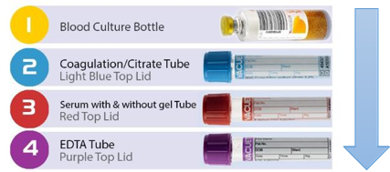
Plasma – Sodium Citrate | Light blue top | 
Serum, no additive | Red top | 
Serum, with clot activator / gel separator | Red top with Yellow ring | 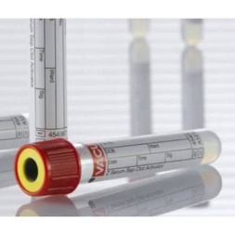
Whole blood – Lithium Heparin | Green top or Royal Blue Top | 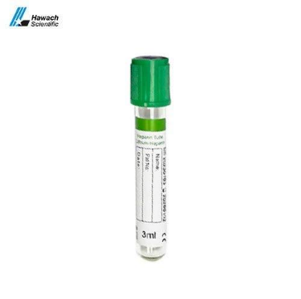
Blood culture | Aerobic/anaerobic culture bottle | 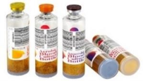
Urine | Yellow top container | 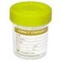
Cerebrospinal fluid (CSF) | Sterile screw-top universal container | 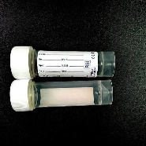
Stool | Brown top container | 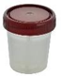
Swab (bacterial culture) | Amies +/- charcoal transport swab | 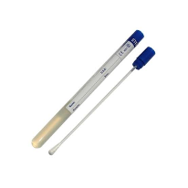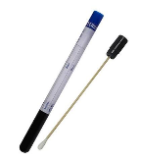
Sputum | Yellow top container, in a biohazard bag | 
Tissue biopsy | Formalin pot | 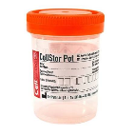
Nasopharyngeal & oropharyngeal swab (molecular/PCR) | Viral transport medium (VTM) | 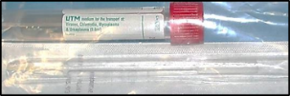

Specimen Collection Procedures

Venipuncture
The image below shows the preferred sites for collection of blood;
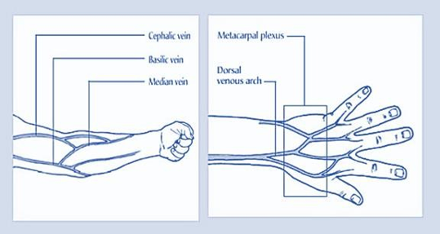
The order of which to draw blood is shown in the diagram below;


General Procedure:
- Reassure the patient that only the minimum amount of blood required for testing will be drawn.
- Assemble equipment appropriate to the patient's physical characteristics.
- Wash hands and put on gloves.
- Position the patient with the arm extended to form a straight line from shoulder to wrist.
- Select the appropriate vein. The median cubital, basilic, and cephalic veins are most frequently used; veins become more prominent if the patient closes their fist tightly.
- Factors to consider in site selection:
- Avoid extensive scarring or healed burn areas.
- Do not obtain specimens from the arm on the same side as a mastectomy.
- Avoid areas of haematoma.
- If an IV is in place, samples may be obtained below it, but never above it.
- Do not obtain specimens from an arm with a cannula, fistula, or vascular graft.
- Allow 10–15 minutes after a transfusion is completed before obtaining a blood sample.
- Apply the tourniquet 3–4 inches above the collection site. Never leave it on for over 1 minute — if used only for preliminary vein selection, release and reapply after two minutes.
- Clean the puncture site with a 70% alcohol swab in an outward spiral from the penetration point. Allow the skin to dry; do not touch the site after cleaning.

Venipuncture using a vacutainer:
- Attach the appropriate needle to the hub, twisting it tight.
- Remove the plastic cap over the needle and hold bevel up.
- Pull the skin tight just below the puncture site.
- Penetrate the skin and vein in one smooth motion, in line with the vein.
- Insert the first tube (following the proper order of draw) into the hub; blood should flow into the evacuated tube.
- After blood starts to flow, release the tourniquet and ask the patient to open their hand.
- When flow stops, remove the tube. If multiple tubes are needed, follow the correct order of draw to avoid cross-contamination and erroneous results.
- Place a gauze pad over the puncture site and remove the needle. Apply pressure for at least 2 minutes; apply a fresh bandage once bleeding stops.
- Dispose of the needle/hub into a sharps container. Label all tubes with the patient's details, initials, date, and time.
Do not shake or mix tubes vigorously. All labels on the specimen container must correlate with those on the laboratory request form.

Venipuncture using a syringe:
- Place a sheathed needle or butterfly on the syringe and turn the bevel up.
- Pull the skin tight just below the puncture site and penetrate the skin and vein in one motion.
- Draw the desired amount of blood, pulling back slowly on the plunger.
- Release the tourniquet, then apply a gauze pad and remove the needle, applying pressure for at least 2 minutes.
- Transfer blood into the appropriate tubes as soon as possible using a needleless device. Gently invert additive tubes 5–8 times.
- Dispose of the syringe and needle in the designated waste bin and sharps container.

Venipuncture in infants/children:
- Confirm the patient's identification and secure the patient in a stable position.
- Assemble required supplies and select the collection site.
- Proceed as for routine phlebotomy; if the child is old enough, collect as for an adult.

Specialised blood sample: Neonatal bilirubin samples
Container: red-top tube. Specimen: serum.
- Following blood collection;
- Completely wrap the specimen container in aluminium foil to protect it from light.
  - 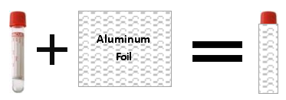
- Place the wrapped container and requisition form in a biohazard carrier bag and transport to the laboratory.

Blood culture collection

Container: blood culture bottle (aerobic and anaerobic, where adult collection is recommended).

Procedure:
- Select the appropriate vein as for routine venipuncture.
- Apply the tourniquet and clean/sterilize the puncture site as above. Avoid re-palpating the vein after disinfecting; if necessary, apply alcohol to a gloved finger and allow it to dry first.
- Penetrate the skin and vein with a fresh, sterile needle.
- Inject a maximum of 10 mL of blood through the central ring of the bottle's rubber stopper.
- Mix the blood thoroughly with the broth in the bottle.
- Dispose of the syringe and needle appropriately
- Label the bottle with the patient's identification details.
- Transfer the inoculated bottle to the laboratory immediately. If transport is delayed, incubate the bottle at 36 ± 1°C and deliver within 24 hours.
One aerobic and one anaerobic bottle is recommended for adults.

Stool collection

Container: Sterile Container, Brown Cap.

Notes for clinicians
- Collect into a clean, wide-mouthed container or collection “hat”; do not contaminate with water or urine.
- A bedpan specimen is acceptable if it contains only stool.
- Newspaper or plastic wrap may be draped over the toilet seat to assist collection.
- Do not submit diapers.
- Collect only one sample per day. Inpatients should not have a routine stool culture ordered after 3 days of admission unless food poisoning is suspected.
- Transport to the laboratory within 24 hours; refrigerate if there will be any delay.

Procedure:
- Wash hands before and after collection.
- Urinate before collecting the stool so that you do not get any urine in the stool sample (female only). Do not urinate while passing the stool.
- Pass stool into a sterile cup.
- You may also tape cling or plastic wrap across the toilet to catch the stool, please see picture below.
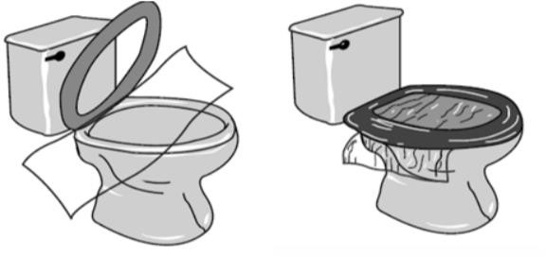
- Either solid or liquid stool can be collected.
- If you have diarrhea, a plastic bag taped to the toilet seat may make the collection process easier; the bag is then placed in a sterile cup.
- Do not collect the sample from the toilet bowl.
- Do not mix toilet paper, water, or soap with the sample.
- Place the lid on the container and label container with your name and the date the stool was collected.
- Deliver stool specimen the same day it is collected to the laboratory.
Infants with diarrhoea are encouraged to provide a rectal swab instead.

Specialised stool sample: Acute Flaccid Paralysis (AFP) sample for polio investigation
- Collect two stool samples, each about the size of an adult's thumb (or at least 5 mL if watery), at least 24 hours apart, both within 14 days of paralysis onset for the most accurate results.
- Place in separate, clean, dry, leak-proof, tightly sealed containers.
- Label each container with the patient's name, EPIID code, collection date, and whether it is the 1st or 2nd sample.
- Store immediately at 4–8°C (do not freeze) and send to the VNH Laboratory Department.

Urine collection

Container: sterile container, yellow cap. Early-morning mid-stream collections are preferred; samples must reach the laboratory within 2 hours or be refrigerated and delivered within 24 hours (overnight refrigeration is acceptable). Approximately 10-20mLs is required unless otherwise stated.

Procedure:
Female patients:
- Sit comfortably and clean the vaginal area front-to-back with soap, then rinse with a moistened pad, using each pad once.
- Remove the lid of the cup and hold the cup with your fingers on the outside.
- First-catch urine: Collect urine directly into cup – fill cup half full.
- Clean-catch urine: Pass a small amount of urine into the toilet first. Then move cup into urine stream and collect a mid-stream sample – fill cup half full.
- Replace and tighten the lid.

Male patients:
- Retract the foreskin if uncircumcised and clean the glans (head of penis).
- Remove the lid of the cup and hold the cup with your fingers on the outside.
- First-catch urine: Collect urine directly into cup – fill cup half full.
- Clean-catch urine: Pass a small amount of urine into the toilet first. Then move cup into urine stream and collect a mid-stream sample – fill cup half full.
- Replace and tighten the lid.
Consult the Microbiology Officer In-Charge or Senior Scientist for any queries on appropriate procedure.

Specialised urine sample: Urine for Cytology
Urine collection for cytology investigation requires a 2-3 hour, whole output specimen, greater than 50mLs. Early morning urines are NOT satisfactory due to advanced cellular degeneration in urine overnight. The procedure for collection is the same as above, clean-catch urine is required. Cells degenerate quickly in acid medium, therefore, all urine for cytology should immediately be mixed with an equal volume of 50% alcohol to enhance fixation. Urines must then be immediately transported to the lab.

Sputum collection
Sputum should be collected in a sterile plastic container. Sputum is mucous or phlegm coughed from deep in the lungs. It is not saliva. Salivary samples will be rejected.
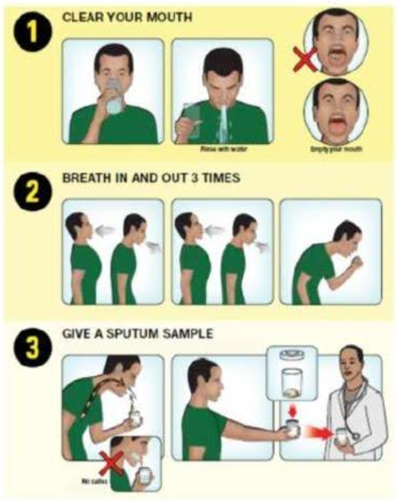
- Take a sterile plastic container.
- Ensure mouth is free from foreign matter – rinse with water prior to collection.
- Take deep breaths through your mouth and cough up mucous from deep in your lungs.
- Open the container and hold it close to your mouth. Cough the mucous into the container.
- 1-2 teaspoons of specimen is adequate.
- Once collected screw lid tightly.
- Write patient information and clinician information on specimen and bag in biohazard safety bag.
- Deliver to laboratory as soon as possible on the same day. Refrigerate if delayed.
- NOTE: a separate form and specimen is required for each test requested.

Specialised sputum sample: Mycobacterium tuberculosis investigation
A series of at least three samples on three successive days is recommended; early-morning sputum is preferred. Should the patient be unable to provide sputum gastric aspirate can be collected instead.

Procedure: Gastric wash
- Explain the procedure to the patient
- Ensure appropriate PPE is worn.
- Collect early in the morning, prior to eating, drinking and oral hygiene.
- Position patient appropriately (supine or semi-recumbent)
- Insert a nasogastric tube if not already in place.
- Aspirate gastric contents using a sterile syringe.
- If insufficient volume is obtained, sterile water may be instilled and re-aspirated according to clinical procedures.
- Transfer sample into sterile container immediately and secure the lid.
- Label specimen and transport immediately to laboratory at room temperature.
- Do not delay transport – TB culture is time-sensitive and must be prioritised.
Urgent AFB stains will only be performed after hours following prior consultation with the microbiology scientist.

Semen collection

Container: sterile yellow-capped container.

Note for clinicians
- Collect after a minimum of 48 hours, and no more than 7 days, of sexual abstinence.
- Semen collected in a latex condom or by coitus interruptus is not acceptable for evaluation.
- If you are unable to collect by masturbation, contact your physician to discuss an alternative collection method.
- Deliver to the laboratory within 1 hour of collection, or sperm motility may decrease and affect the result.
- Keep the sample close to the body for temperature stability — never refrigerate, unless the test is for count and morphology only (post-vasectomy).

Procedure:
- Preparation: urinate first; wash the genital area with warm water only (no soap); wash and dry hands; remove lid from specimen cup; avoid touching the inside of the container or lid.
- Collect by masturbation directly into a sterile, wide-mouthed glass or plastic container.
- Replace container lid immediately after.
- Wash hands, then label the container with name, date, and time.
- Keep sample at body temperature until given to laboratory staff.
- Deliver to laboratory within 60 minutes in a biohazard carrier bag with the requisition form.

Nasopharyngeal swab collection
Container: appropriately sized NP swab and viral transport medium or amies transport medium (+/-charcoal). Note VTM/UTM is used for molecular testing, amies is used for microbiological culture.
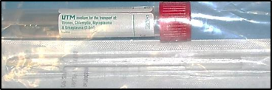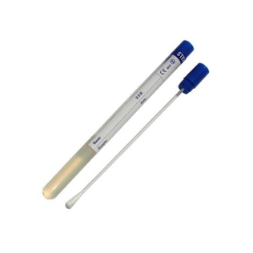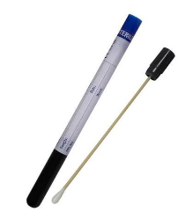
VTM/UTM NP swab Amies swab +/- charcoal

Note for clinicians
Collect within 7 days of symptom onset.

Procedure:
- Explain the procedure to the patient.
- Wash hands and put on appropriate PPE (at minimum gloves and a face mask).
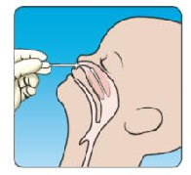
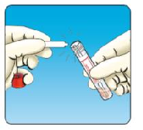
- If there is visible nasal mucus, ask the patient to gently clear it with a tissue first — the virus is found in the cells lining the nose, not in the mucus itself.
- Seat the patient comfortably, ideally in a high Fowler's position with the head supported; a second person may help.
- Tilt the patient's head back slightly.
- Advance a flexible swab gently along the floor of the nose (straight back, not upward) until reaching the posterior nasopharynx.
- Once gentle resistance is felt, rotate the swab several times, then withdraw it.
- Break off or seal the swab into the transport medium.
- Remove PPE, wash hands
- Label the specimen, and transport it with the completed requisition form.

Oropharyngeal swab collection
Container: appropriately sized flocked swab and viral transport medium or amies transport medium (+/-charcoal). Note VTM/UTM is used for molecular testing, amies is used for microbiological culture.

VTM/UTM OP swab Amies swab +/- charcoal

Note for clinicians
Collect within 7 days of symptom onset.

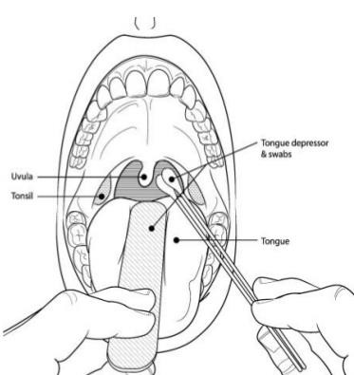
Procedure:
- Tilt the patient's head back approx. 70º.
- Use a tongue depressor to assist visibility.
- Advance a flexible swab to the tonsil region slowly, with a steady motion
- Once resistance is met, rotate the swab several times and withdraw it.
- Break off or seal the swab into the transport medium.
- Remove PPE, wash hands.
- Label the specimen, and transport with the completed requisition form.

Culture swab collection (all general bacteriology)
Container: For any general bacterial swab culture (e.g. wound, eye, ear, nasal, through, high vaginal etc) please collect using amies/charcoal transport medium.

Amies swab +/- charcoal

Procedure:
- Explain procedure to the patient and wear appropriate PPE.
- Expose the site to be swabbed.
- Where pus or exudate is present, sample directly from it; otherwise moisten the swab tip first with sterile saline for a dry site.
- Roll the swab firmly over the affected area, covering as wide a surface as possible, to collect adequate material.
- NOTE: A dry swab with no visible material may be rejected.
- Avoid contaminating the swab with surrounding skin, mucosa, or normal flora.
- Return the swab to its transport medium immediately and seal (or break) as required by swab type.
- Label the swab and request form, including the precise anatomical site i.e. left ear or wound right shin.
One swab is generally sufficient for processing on receipt; collect a second swab only if a specific additional test (e.g. a separate viral swab) is also requested. Deliver to the laboratory within 2 hours of collection.

Cerebrospinal fluid (CSF) collection
Container: Sterile leak-proof screw-cap container.

Procedure:
- CSF is collected by a clinician via lumbar puncture; the laboratory does not perform the puncture itself but supplies the correct tubes on request.
- Explain the procedure to the patient.
- Ensure strict aseptic technique is used during invasive sampling.
- Collect via lumbar puncture into 2–3 separate sterile screw-cap tubes, numbered/labelled (1, 2, 3) in the order they are drawn.
- Label each tube with the patient's details, and clearly mark the collection order, since different tubes may be prioritised for different tests (e.g. the least blood-stained tube for cell count).
- Do not refrigerate CSF intended for culture — transport at room temperature and send to the laboratory immediately.
- Hand-deliver to the laboratory without delay; do not place CSF in a pneumatic tube system or leave it for routine collection rounds.
All CSF samples are treated as urgent on receipt, regardless of how the request form is marked.

Other sterile body fluids collection
Container: Sterile leak-proof screw-cap container. Includes pleural fluid, ascitic (peritoneal) fluid, synovial fluid, pericardial fluid, and any other normally sterile cavity aspirates.

Procedure:
- Explain the procedure to the patient.
- Ensure strict aseptic technique is used during invasive sampling.
- Wear appropriate PPE.
- Collect fluid directly from sterile site using clinician-performed aspiration.
- Ensure adequate volume is collected to allow for division into multiple test containers.
- Label all specimens with patient identifies and precise site i.e. right pleural fluid.
- Transport immediately to the laboratory. Do not refrigerate unless instructed to.
- Clearly indicate suspected diagnosis (e.g. TB, sepsis) on request form.

Smear collection
Container: glass microscopy slides with a labelled frosted end, plus fixative (95% ethanol /Cytofix /Sprayfix). Slides and fixative are available from the laboratory storeroom.

Procedure:
Use this procedure for any smear taken directly from a tissue surface — for example, an ulcerated lesion, open wound, skin lesion, or mucosal surface where scrape cytology has been requested. It is not required for smears produced from aspirated or collected fluids.
- Assemble equipment: labelled glass slides, fixative (95% ethanol or equivalent), a clean spatula or scalpel blade, and PPE (gloves, mask where appropriate).
- Label the frosted end of each slide clearly with the patient's name, date of birth, date of collection, and anatomical site before starting — never rely on labelling after collection.
- Gently clean any overlying surface debris or crusting from the lesion with a dry swab if necessary, to expose fresh material beneath.
- Using a spatula or the flat of a scalpel blade, apply firm, even pressure and scrape across the surface of the lesion in one smooth motion to collect a representative sample of cells.
- Immediately smear the collected material thinly and evenly across the central portion of the slide in a single sweep — a thick smear will obscure cellular detail.
- Immerse the first 1–2 slides immediately (within seconds) in 95% ethanol (or Cytofix / Sprayfix) for wet fixation. Any delay results in air-drying artefact that may hamper or prevent cytological assessment.
- Allow any remaining thinner smears (slides 3–4 if prepared) to air-dry at room temperature; these provide a complementary preparation for certain staining techniques.
- After a minimum of 30 minutes in fixative, wet-fixed slides may be removed, allowed to drain, and placed in a slide container for transport.
- Complete the cytology laboratory request form fully (including site, clinical history, and date of onset if relevant) and dispatch slides with the form to the laboratory promptly.
One smear per anatomical site per slide. If multiple sites are sampled, use a separate clearly labelled slide for each. Consult the Cytology section if uncertain about fixative requirements for a specific specimen type.

Specialised smear sample: Pap smear (cervical smear)
Cervical smear can be carried out by a trained cytologist, or a trained health care worker.

Procedure:
- Confirm the patient's identity and that the procedure has been explained and consented to.
- Label the frosted end of the slide clearly with the patient's name, date of birth, date of collection, and 'Cervical smear' before beginning.
- Position the patient in the dorsal lithotomy position and insert a bivalve speculum to expose the cervix under adequate light.
- Using an Ayre spatula (ectocervix) or endocervical brush (endocervical canal), rotate the sampling device 360° firmly against the cervix, ensuring contact with the transformation zone.
- Transfer the collected material immediately and evenly to the centre of the slide with a single, smooth spreading motion.
- Fix the slide immediately (within seconds) by flooding with 95% ethanol, or by spraying with Cytofix or Sprayfix at approximately 20 cm distance. Do not allow the smear to air-dry before fixation — air-drying artefact will hamper or prevent cytological assessment.
- Leave the slide in fixative for a minimum of 30 minutes before removing, draining, and placing in a slide transport container.
- Complete the cytology request form with the patient's clinical details, last menstrual period, any hormone use, previous abnormal smear history, and clinical indication.

Fine Needle Aspiration (FNA)
Container: glass microscopy slides plus fixative (95% ethanol / Cytofix / Sprayfix), sterile 21–23G needle, 10–20 mL syringe, and a syringe holder/pistol grip where available. All equipment and fixatives are prepared by the Cytology section. Contact the Cytology section before the procedure — sufficient advance notice is required for the Cytology Scientist to prepare equipment and fixatives.
The Cytology Scientist must be present at the time of collection for immediate processing of the sample; do not proceed if the Scientist is not available.

Procedure:
- Confirm the patient's identity, explain the procedure, and obtain consent. Position the patient comfortably with the target lesion accessible and well-supported.
- Label the frosted end of each slide with the patient's name, date of birth, date of collection, and anatomical site before starting.
- Clean the overlying skin with an alcohol swab and allow to dry. Sterile technique is required throughout.
- Palpate and stabilise the lesion between the fingers of the non-dominant hand. For deep or non-palpable lesions, ultrasound or imaging guidance is required — coordinate with the relevant clinical team and notify the Cytology section accordingly.
- Attach the needle to the syringe (or syringe pistol) and, with negative pressure applied, insert the needle into the lesion with a single firm movement.
- Maintaining negative pressure, move the needle back and forth through the lesion several times using short rapid strokes (5–10 passes) across different planes to sample adequately.
- Release the negative pressure before withdrawing the needle — failure to do so will aspirate material into the barrel of the syringe where it cannot be retrieved.
- Withdraw the needle and apply gentle pressure to the puncture site with a gauze pad for at least 2 minutes.
- Detach the needle, draw air into the syringe, reattach the needle, and gently expel the aspirated material onto the centre of a labelled slide.
- The Cytology Scientist present will prepare smears immediately from the expelled material, applying wet fixation (95% ethanol or spray fixative) and/or air-drying as appropriate for the staining methods planned.
- Any residual material in the needle hub may be rinsed into a small volume of saline or cell-preservative medium provided by the Cytology section for additional cell block preparation.
- Complete the cytology request form fully — include the anatomical site, clinical history, size and character of the lesion, and any relevant imaging findings — and dispatch with the slides.
A minimum of 2–4 passes is generally recommended for adequate cellularity, though the number will depend on the lesion type and material obtained. If a cyst is aspirated, collect the fluid into a sterile container and hand it directly to the Cytology Scientist for processing.

Tissue Biopsy collection
Container: Pre-filled formalin pot. Ensure adequate container size to fully immerse specimen without compression.

Note for clinicians
Histology specimens must be immediately fixed in formalin to prevent autolysis and preserve tissue architecture. Delay in fixation will significantly compromise diagnostic quality. Do not refrigerate formalin-fixed specimens.

Procedure:
- Confirm patient identification and ensure correct specimen request form is completed, including full clinical history and anatomical site of collection.
- Explain the procedure to the patient and ensure informed consent has been obtained by the treating clinician.
- Wear appropriate PPE (gloves, mask, and eye protection where splash risk exists).
- Collect tissue specimen using sterile surgical technique appropriate to the procedure (e.g. biopsy, excision, endoscopy, or punch biopsy).
- Immediately transfer the fresh tissue specimen into the pre-filled formalin container. Ensure the specimen is fully submerged.
- Ensure the volume of formalin is at least 10 times the volume of the tissue specimen to allow adequate fixation.
- Do not crush, squeeze, or dry the specimen prior to fixation, as this will distort histological architecture.
- If multiple specimens are taken from different sites, place each in a separate, clearly labelled formalin pot indicating the exact anatomical site.
- Securely close the container lid immediately to prevent leakage.
- Complete and attach the histology request form, ensuring all relevant clinical information and suspected diagnosis is included.
- Transport specimens to the laboratory at room temperature as soon as possible.
- Ensure all formalin containers are placed in appropriate biohazard transport bags and handled according to chemical safety guidelines.

Handling and Transportation of Specimens to VNH Laboratory

Biohazard carrier bag
All specimens must be transported to the laboratory in a sealed biohazard carrier bag, with the requisition form placed in the bag's outer document pocket (not in direct contact with the specimen).
- Tubes containing blood must be placed a biohazard specimen bag.
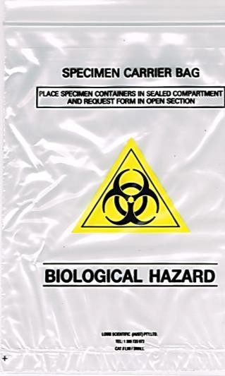
- Urine specimens and other biological fluids must be placed in separate biohazard bags. For example: Do not put a tube of blood and a urine specimen in the same bag.
- Ensure that the urine containers are tightly closed before being placed in the bags.
- The requisition accompanying the specimen should be folded and placed in the pouch on the outside of the bag.
- Do not put the requisition in the same compartment as the specimens.
- The label identifying the patient must be placed directly onto the specimens and not on the bag. Specimens identified only on the bag, will be regarded as not identified and will be rejected by the laboratory.
- Make sure the bags are tightly closed (same principle as "Ziploc" bags).

Specimen delivery
All specimens must be delivered in the correct specimen containers, inside biohazard bags, with sample request form completed. Sample collected during working hours should be delivered to the reception desk for reception and registration. Specimens received after hours should be delivered to the reception desk with a special note on the request form alerting the on-call scientist to the urgent or unusual nature of the specimen. A phone call ahead must be made to the on-call staff.

Customer feedback and complaints
The Medical Laboratory Services is committed to continual improvement and actively seeks feedback from its users to ensure that laboratory services continue to meet the needs and expectations of clinicians and patients.
To support this commitment, the laboratory conducts an annual customer satisfaction survey involving hospital wards, outpatient departments, and private medical clinics. The survey evaluates key aspects of laboratory performance, including the quality and reliability of test results, turnaround times, communication, specimen collection services, accessibility of laboratory staff, and overall customer satisfaction. Feedback obtained through these surveys is reviewed by laboratory management and incorporated into quality improvement activities, corrective actions, and service planning where appropriate.
In addition to the annual survey, compliments, suggestions, and complaints are welcomed at any time and are reviewed in accordance with the laboratory's Quality Management System. All feedback is documented, investigated where necessary, and used as an opportunity to improve laboratory services. Tabulated below are the nature of the complaint/feedback and who it should be directed.
Nature of Complaint | Person the complaint should be directed to
Minor (e.g. need another copy of laboratory result, delay result, blood not collected etc.) | Head of Laboratory section concerned (specific medical lab scientist)
Serious (verbal or written complaint) e.g. wrong  blood bag unit issued; urgent lab investigation not carried out etc. | QC Officer or  Principal Medical Laboratory Officer
Major incidents (e.g. fire in the laboratory, prolong power failure etc.) | Principal Medical Laboratory Officer
Refer to Annexure 7 for the Customer Compliment and Complaint Form.

Departmental Services
The general policy below applies to every department unless stated otherwise:
- Specimen delivery: specimens collected during working hours go to laboratory reception for registration; after-hours specimens are delivered to reception with an urgency note for the on-call scientist (and a phone call ahead, where possible).
- Processing: testing is carried out under quality-controlled, standardized procedures set out in each section's Standard Operating Procedures, to ensure validated, quality-assured reports.
- Delivery of test reports: results are placed in the relevant ward pigeonhole; the collecting clinician/nurse signs the Result Register Log Book.
If you are viewing the handbook online, please Ctrl+click on the department you are interested in, to go straight there.
Department | Section
Haematology | 13
Blood Bank / Transfusion Services | 14
Serology | 15
Biochemistry | 16
Microbiology | 17
Tuberculosis | 18
Molecular | 19
Histology | 20
Cytology | 21
Other services | 22
Department-specific test tables below give the routine and urgent turnaround time for each test.
The Flag column:
- C = CRITICAL (a defined critical-value alert and phone-notification requirement);
- S = SEND-AWAY (not processed on-site; referred overseas).

Haematology Services
These activities are carried out under strict quality controlled, approved standardised procedures stated in the Haematology Standard Operating Procedures to ensure that the quality and validated results are reported/dispatched.
Services include malaria diagnostics. INR and electrolytes are treated as sensitive tests and are processed immediately regardless of the urgency.

Test Directory
Test | Sample | Routine TAT | Urgent TAT | Flag
Full Blood Count (FBC) | 4mL Whole blood – EDTA | 1 hour | 15-30 min
White Blood Cell Differential Count | Whole blood – EDTA | 1 hour | 30 min
Reticulocyte Count  Reference range – Adults 0.2-2%; Infant 2-6% | 4mL Whole blood – EDTA | 4 hours | 1 hour
Peripheral Blood Film Examination  *A blood film is not routinely done on FBC requests unless specifically requested for. We are trying to do films on all abnormal FBC results as a routine but only when special trained  blood films expertise scientist are available. | 4mL Whole blood – EDTA | 24 hours | 2 hours
Erythrocyte Sedimentation Rate (ESR)  Reference range: Male 0-15mm/hr; Female 0-20mm/hr | 4mL Whole blood – EDTA | 2 hours | 1.5 hour
White Blood Cell Count – Manual | 4mL Whole blood – EDTA | 1 hour | 30 min
Prothrombin Time (PT) & INR – Automated  Normal range 12-16sec  Therapeutic range: 2.5-4 | 4.5mL Plasma – Sodium Citrate | 1 hour | 30 min | C
International Normalised Ratio (INR) – Manual  Therapeutic range: 2-4 | 4.5mL Plasma – Sodium Citrate | 1 hour | 30 min | C
Malaria Rapid Diagnostic Test (RDT) | 4mL Whole blood – EDTA | 1 hour | 30 min
Malaria Microscopy | 4mL Whole blood – EDTA | 2 hours | 1 hour
Microfilariae Parasite Screening Microscopy  This specimen should be collected at night-time after 2200hrs to 0400hrs (Peak 2400hrs) | 4mL Whole blood – EDTA | 2 hours | NA
Phlebotomy (Bleeding Time) | At bedside | 30 min | 15 min

Critical values (phoned to requesting clinician once verified):
Test | Critical low | Critical high
Prothrombin Time | — | > 17 sec
Haemoglobin (0–7 weeks) | ≤ 8.0 g/Dl | ≥ 24.0 g/Dl
Haemoglobin (> 7 weeks / adult) | ≤ 8.0 g/Dl | ≥ 20.0 g/Dl
INR | — | ≥ 5.0
Leukocytes | — | ≥ 100.0 ×10⁹/L
Absolute Neutrophil Count / Neutrophils | ≤ 0.5 ×10⁹/L | —
Platelets | ≤ 40 ×10⁹/L | ≥ 1000 ×10⁹/L
CSF White Blood Cell Count | — | ≥ 100.0 cells/Μl

Delivery of test results
Haematology laboratory reports will be placed in each respective wards’ pigeonhole. Any clinician picking up the results at the laboratory reception must enter their name, signature and collection time on the book provided.

Blood Bank / Transfusion Services
These activities are carried out under strict quality controlled, approved standardized procedures stated in the Blood Transfusion Standard Operating Procedures to ensure that the blood units dispensed are safe and appropriate for each specific patient’s need. Includes donor recruitment. Cryoprecipitate has the longest lead time of all blood products — plan ahead.

Special requirements for sample collection
- The tube must be accurately and clearly labelled in ink at the bedside, with the patient positively identified.
- All details on the Blood Transfusion Request Form must be completed and signed by the clinician.
- Relevant clinical history (previous pregnancy, haemolysis-causing drugs, previous transfusions) should be included on the form.

Test Directory
Test | Sample | Routine TAT | Urgent TAT | Flag
ABO and Rh(D) Blood Grouping | 4mL Whole Blood – EDTA or Serum Red top | 30 min | 15 min
Crossmatch Compatibility Testing | 4mL Whole Blood – EDTA or Serum Red top | 2 hours | 1 hour
Coomb’s Test (DCT/ICT) | 4mL Whole Blood – EDTA or Serum Red top | 1 hour | 30 min
Indirect Antiglobulin Test (IAT) | 4mL Whole Blood – EDTA or Serum Red top | 1 hour | 30 min
Packed Red Blood Cell (PRBC) Prep & Issue | N/A | 2 hours | 1 hour
Fresh Whole Blood Prep & Issue | N/A | 2 hours | 1 hour
Fresh Frozen Plasma (FFP) Prep & Issue | N/A | 2 hours | 1 hour
Platelet Concentrate Prep & Issue | N/A | 4 hours | 2 hours
Platelet-Rich Plasma (PRP) Prep & Issue | N/A | 4 hours | 2 hours
Cryoprecipitate Prep & Issue | N/A | 24 hours | 24 hours
Blood Donor Recruitment & Assessment | N/A | 20 min | 15 min
Blood Donor Collection | N/A | 30 min | 15 min

Clinical use of blood
Transfusion should only be used to treat a condition causing significant morbidity or mortality that cannot be managed effectively by other means. The need for transfusion can often be reduced by early treatment of anaemia, correction of iron stores before planned surgery, use of IV replacement fluids, and good surgical/anaesthetic management. Blood products carry risk of transfusion-transmissible infection (HIV, hepatitis B/C, syphilis, malaria, Chagas disease) and of acute or delayed reactions — see Annexure 1. Blood donated by family/replacement donors carries a higher risk of transfusion-transmissible infections than blood donated by voluntary non-remunerated donors. Paid blood donors generally have the highest incidence and prevalence of transfusion-transmissible infections. Blood should not be transfused unless it has been obtained from appropriately selected donors, has been screened for transfusion-transmissible infections and tested for compatibility between the donor’s red cells and the antibodies in the patient’s plasma, in accordance with national requirements.

Setting up and monitoring an infusion
- Re-check compatibility labels against the recipient’s identification immediately before infusing — there must be no discrepancy. Record the re-check with date/time.
- Use an administration set with a filter, changed at least every 24 hours or after 4–6 units. Flush the line with a blood-compatible solution before and after infusion. Do not add IV medication directly to blood.
- Most units are transfused over 1½–2 hours in adults with symptomatic anaemia, and should not exceed 4 hours, to limit bacterial proliferation and haemolysis risk at room temperature.
- A unit not used in the ward must be returned to the Blood Bank within 30 minutes of issue; blood must never be left at room temperature or in a ward fridge for more than 30 minutes.
- Observe the patient closely in the first 5–10 minutes (when most life-threatening reactions occur) and continue observation throughout and after the transfusion. Report suspected reactions immediately, or within 24 hours, to the Blood Bank and the responsible doctor.

Available blood products
Product | Volume | Indication
Whole Blood | 300–450mL | Major transfusions, to increase red cell mass and blood volume
Packed Red Blood Cell (PRBC) | 250–350mL | Moderate to severe symptomatic anaemia
Fresh Frozen Plasma (FFP) | 200–300mL | Coagulation factor deficiency (e.g. warfarin overdose, DIC); not a plasma volume expander
Platelet Concentrate | 50–60mL | Bleeding due to thrombocytopenia; usually 6 adult units, or 1 unit per 10–12 kg in children
Cryoprecipitate | 30 – 40mL | Treatment of prolong PT or APTT, volume replacement, Haemophilia A AND massive haemorrhage with low fibrinogen

Risks of Transfusion
In some clinical situations, transfusion may be the only way to save life or rapidly improve a serious condition. However, before prescribing blood or blood products for a patient, it is always essential to weigh up the risks of transfusion against the risks of not transfusing.

Red Cell Transfusion
- The transfusion of red cell products carries a risk of serious haemolytic transfusion reactions.
- Blood products can transmit infectious agents, including HIV, hepatitis B, hepatitis C, syphilis, malaria and Chagas disease to the recipient.
- Any blood product can become contaminated with bacteria and very dangerous if it is manufactured or stored incorrectly.

Plasma Transfusion
- Plasma can transmit most of the infections present in whole blood.
- Plasma can also cause transfusion reactions.
- There are few clear clinical indications for plasma transfusion. The risks very often outweigh any possible benefit to the patient.

Blood Safety
The quality and safety of all blood and blood products must be assured throughout the process from the selection of blood donors through to their administration to the patient. This requires:
- The establishment of a well-organized blood transfusion service with quality systems in all areas.
- The collection of blood only from voluntary non-remunerated donors from low-risk populations and rigorous procedures for donor selection.
- The screening of all donated blood for transfusion-transmissible infections: HIV, hepatitis viruses, syphilis and, where appropriate, other infectious agents, such as Chagas disease
- and malaria.
- Good laboratory practice in all aspects of blood grouping, compatibility testing, component preparation and the storage and transportation of blood and blood products.
- A reduction in unnecessary transfusions through the appropriate clinical use of blood and blood products, and the use of simple alternatives to transfusion, wherever possible.

Blood Group Compatibility
For safe transfusion practice compatible blood must be given. When a transfusion is given, it is preferable that patients receive blood of the same ABO and Rh (D) group, however in an emergency, if the required red cell blood group is unavailable, a patient may be given other red cell groups as shown below.
Red cell compatibility chart:
Please see Annexure 1 for details about blood transfusion adverse reactions.

BLOOD DONATION
Blood donation is a vital component of healthcare and plays an essential role in saving lives. A safe and adequate supply of donated blood ensures that hospitals can provide timely treatment for patients experiencing medical emergencies, undergoing surgery, or requiring ongoing transfusion therapy.
VNH Hospital Laboratory Blood Bank Department Accept routine blood donors in week days, emergency donors during weekends and conducts mobile blood drive to business houses and NGO.

Donor Acceptance Criteria
A donor may be accepted for blood donation if all of the following criteria are met:
- Age:
  - Donor is between 18 and 60 years of age - donors outside of this age range will not be accepted
  - Body Weight - minimum body weight of 50 kg for a standard 450 mL whole blood donation.
- General Health:
  - Good general health
  - Well on day of donation
  - Free from fever or signs of acute illness
  - No active infection requiring medical treatment
- Haemoglobin Level
  - Female donors: ≥12.5 g/dL
  - Male donors: ≥13.5 g/dL
  - Haemoglobin shall be assessed before donation using an approved screening method.
- Vital Signs
  - Blood pressure: 100–180 mmHg systolic and 50–100 mmHg diastolic
  - Pulse: 50–100 beats per minute, regular
  - Body temperature: ≤37.5°C
- Medical History
  - Complete the donor health questionnaire
  - Pass the confidential medical interview
  - Have no medical condition that may endanger the donor or recipient
  - Not be taking medications that are considered unsuitable for blood donation
- Infectious Disease Risk Assessment
  - No history or current evidence of blood-borne infectious diseases.
  - No high-risk behaviours associated with HIV, Hepatitis B, Hepatitis C, or other transfusion-transmissible infections.
  - No recent exposure requiring temporary deferral.
  - Temporary deferral will apply to donors traveling to an area experiencing outbreaks of diseases that may be transmitted through blood (e.g., HIV, Malaria, dengue, Zika virus, chikungunya, or other emerging infections)
- Pregnancy and Breastfeeding
  - Pregnant women shall not donate blood
  - Breastfeeding mothers should only donate after the recommended postpartum period in accordance with national guidelines
- Donation Interval
  - Minimum interval between donations:
    - Male donors: At least 12 weeks (3 months)
    - Female donors: At least 16 weeks (4 months)
- Alcohol and Drug Use
  - The donor shall not be under the influence of alcohol or recreational drugs.
  - Alcohol should not have been consumed within the previous 24 hours, where required by local policy.
- Identification
  - Provide valid identification
  - Be correctly registered in the Blood Bank information system
  - Give informed consent before donation

Blood Unit Acceptance
A donated blood unit shall be accepted only when:
- Donor eligibility criteria have been satisfied.
- The blood collection process was completed without significant complications.
- The collection bag contains the required blood volume.
- All donor records and labels are complete and accurate.
- Samples for mandatory infectious disease screening have been collected.
- The blood unit passes all required quality checks before release for processing or transfusion.

Reasons for Deferral
A donor shall be deferred if any of the following apply:
- Low haemoglobin.
- Fever or acute illness.
- Pregnancy.
- High-risk exposure to infectious diseases.
- Recent surgery or blood transfusion.
- Recent vaccination (where applicable).
- Certain chronic medical conditions.
- Medication affecting donor or recipient safety.
- Failure to meet minimum age or weight requirements.
- Any condition identified by the Medical Officer as unsuitable for donation.

BLOOD TRANSFUSION – when a new sample is required
A new pre-transfusion sample shall be requested when:
- The existing sample is more than 72 hours old in recently transfused or pregnant patients.
- Patient identification details are incomplete, incorrect, or inconsistent.
- The specimen is haemolysed, clotted (where anticoagulated blood is required), contaminated, or of insufficient volume.
- Additional testing cannot be completed on the original specimen.
- The laboratory has reason to question the integrity or identity of the sample.
A post-transfusion blood sample shall be collected when:
- A transfusion reaction is suspected.
- The clinician requests assessment of the effectiveness of the transfusion (e.g., post-transfusion hemoglobin or platelet count).
- Additional compatibility testing or serological investigations are required.
- Laboratory policy requires confirmation of blood group or antibody status.

Delivery of test blood results
Blood Transfusion laboratory reports will be placed in each respective wards’ pigeonhole. Any clinician picking up the results at the laboratory reception must enter their name, signature and collection time on the book provided.

Serology Services
These activities are carried out under strict quality controlled, approved standardized procedures stated in the Serology Standard Operating Procedures to ensure that the quality and validated results are reported/dispatched.
Most serology tests run on a 24-hour routine cycle; urgent requests can be escalated to 2 hours. Viral load testing is performed in-house unless out of stock.

Test Directory
Test | Sample | Routine TAT | Urgent TAT | Flag
HIV-1/2 Antibody Screening | 4mL Whole Blood – EDTA or Serum Red Top | 24 hours | 2 hours
HIV-1/2 Confirmatory Testing | 4mL Whole Blood – EDTA or Serum Red Top | 24 hours | 2 hours
HIV-1 Viral Load | 4mL Whole Blood - EDTA | 24 hours | 2 hours
CD4 T-Lymphocyte Count | 4mL Whole Blood - EDTA | 24 hours | 2 hours
Hepatitis B Surface Antigen (HBsAg) | 4mL Whole Blood – EDTA or Serum Red Top | 24 hours | 2 hours
Hepatitis B Viral Load | 4mL Whole Blood - EDTA | 24 hours | 2 hours
Hepatitis C Antibody Test | Serum, plasma or whole blood | 24 hours | 2 hours
Syphilis Rapid Plasma Reagin (RPR) | 4mL Whole Blood – EDTA or Serum Red Top | 24 hours | 2 hours
Syphilis Treponema pallidum (TP) Rapid Test | 4mL Whole Blood – EDTA or Serum Red Top | 24 hours | 2 hours
Dengue RDT (NS1 Antigen and/or IgM/IgG) | 4mL Whole Blood – EDTA or Serum Red Top | 24 hours | 2 hours
Leptospirosis Rapid Diagnostic Test | 4mL Whole Blood – EDTA or Serum Red Top | 24 hours | 2 hours
Leptospirosis Confirmation / Serotyping | 4mL Serum | Weeks | Weeks | S
Dengue Serotyping | 4mL Serum | Weeks | Weeks | S
Autoimmune Antibody Testing (SLE, ANA, anti-dsDNA) | 4mL Serum | Weeks | Weeks | S
Membrane Antibody Testing | 4mL Serum | Weeks | Weeks | S
Measles / Rubella Serology (ELISA) | 4mL Serum | 24 hours | 2 hours
Mumps / Chickenpox Serology | 4mL Serum | Weeks | Weeks | S
Retroviral Studies (beyond HIV) | 4mL Serum | Weeks | Weeks | S

Delivery of test results
Serology laboratory reports will be placed in each respective wards’ pigeonhole. Any clinician picking up the results at the laboratory reception must enter their name, signature and collection time on the book provided.

Biochemistry Services
These activities are carried out under strict quality controlled, approved standardized procedures stated in the Biochemistry Standard Operating Procedures to ensure that the reports dispensed are valid and of quality.
Core chemistry runs on the Cobas C311 / Fujifilm analyser; immunoassay testing runs on the E411 analyser. Available during normal working hours and after hours.

Test Directory
Test | Sample | Routine TAT | Urgent TAT | Flag
Electrolytes & Minerals  (Sodium, Na/Potassium, K/Chloride, Cl/Calcium, Ca/Magnesium, Mg/Phosphate, PO4) | 4mL Serum with activator or Serum or Whole blood - Heparin | 2–3 hours | < 1 hour | C
Bicarbonate (CO₂) | 4mL Serum with activator or Serum or Whole blood - Heparin | 2–3 hours | < 1 hour | C
Renal Function Tests (RFT/Urea/Creatinine, Cr/Estimated Glomerular Filtration Rate, eGFR/Uric Acid, UA) | 4mL Serum with activator or Serum or Whole blood - Heparin | 2–3 hours | < 1 hour
Liver Function Tests  (LFT/Albumin, Alb/Bilirubin, Bil/Alanine Aminotransferase, ALT/Aspartate Aminotransferase, AST/Alkaline Phosphatase ALP/Total Protein, TP/Gamma-Glutamyl Transferase, GGT) | 4mL Serum with activator or Serum or Whole blood - Heparin | 2–3 hours | < 1 hour | C
Lipid Profile  (Total Cholesterol, TC/High-Density Lipoprotein Cholesterol, HDL/Low-Density Lipoprotein Cholesterol, LDL/ Triglycerides, TG) | 4mL Serum with activator or Serum or Whole blood - Heparin | 2–3 hours | < 1 hour
Glucose | 4mL Serum with activator or Serum or Whole blood - Heparin | 2–3 hours | < 1 hour | C
Fasting Glucose | 4mL Serum with activator or Serum or Whole blood - Heparin | 2–3 hours | < 1 hour | C
Glycated Haemoglobin, HbA1c | 4mL Whole Blood - EDTA | 2–3 hours | < 1 hour
Cardiac & Muscle Enzymes  (Creatine Kinase, CK/ Creatine Kinase-MB, CK-MB/Lactate Dehydrogenase, LDH/Amylase, AMY) | 4mL Serum with activator or Serum or Whole blood - Heparin | 2–3 hours | < 1 hour
Inflammation Markers  (C-reactive Protein, CRP/Antistreptolysin O, ASO/Rheumatoid Factor, RF-II/Complement Component 3/4, C3/C4/ Transferrin, TRF) | 4mL Serum with activator or Serum or Whole blood - Heparin | 2–3 hours | < 1 hour
D-Dimer | 4mL Serum with activator or Serum | 2–3 hours | < 1 hour
Thyroid Function Tests  (Thyroid Stimulating Hormone, TSH/Triiodothyronine, T3/Thyroxine, T4) | 4mL Serum with activator or Serum or Whole blood - Heparin | 2–3 hours | < 1 hour
Cardiac Troponin | 4mL Serum with activator or Serum or Whole blood - Heparin | 2–3 hours | < 1 hour | C
CSF & Sterile Body Fluid Chemistry | CSF / sterile fluids | 2–3 hours | < 1 hour
Urine Creatinine | Urine; MID-STREAM | 2–3 hours | < 1 hour
Tumour Markers  (Prostate Specific Antigen, PSA/Alpha-Fetoprotein, AFP/Carcinoembryonic Antigen, CEA/Cancer antigen 125, CA125/Cancer Antigen 19-9, CA19-9) | 4mL Serum with activator or Serum | 2–3 hours | < 1 hour
Pregnancy Marker βhCG | 4mL Serum with activator or Serum | 2–3 hours | < 1 hour
Vitamin B12 | 4mL Serum with activator or Serum | 2–3 hours | < 1 hour
Specialist Iron Studies | 4mL Serum with activator or Serum | Weeks | Weeks | S

Critical values (phoned to requesting clinician once verified):
Test | Critical low | Critical high
Bilirubin Total, Serum (< 1 yr) | — | ≥ 255 µmol/L
Calcium, Total | ≤ 1.625 mmol/L | ≥ 3.25 mmol/L
Creatinine (1 day–4 weeks old) | — | ≥ 132 µmol/L
Creatinine (5 weeks –23 months old) | — | ≥ 176 µmol/L
Creatinine (2yrs-11 yrs) | — | ≥ 221 µmol/L
Creatinine (11yrs- 15 yrs) | — | ≥ 265 µmol/L
Creatinine (≥ 16 yrs) | — | ≥ 884 µmol/L
Creatine Kinase, Total | — | ≥ 10,000 U/L
Glucose (< 4 weeks) | ≤ 2.2 mmol/L | ≥ 22.2 mmol/L
Glucose (≥ 4 weeks) | ≤ 2.7 mmol/L | ≥ 22.2 mmol/L
Magnesium, Serum | ≤ 0.40 mmol/L | ≥ 2.0 mmol/L
Osmolality | ≤ 190 mOsm/kg | ≥ 390 mOsm/kg
Potassium | ≤ 2.5 mmol/L | ≥ 6.0 mmol/L
Sodium | ≤ 120 mmol/L | ≥ 160 mmol/L

Delivery of test results
Clinical Chemistry routine laboratory reports will be placed in each respective wards’ pigeonhole. Any clinician picking up the results at the laboratory reception must enter their name, signature and collection time on the book provided. Final test report during normal working hours for routine testing will be distributed to the lab result box twice daily. One at 12.00pm and at 16.00 pm.

Microbiology Services
These activities are carried out under strict quality controlled, approved standardized procedures stated in the Microbiology Standard Operating Procedures to ensure that the reports dispensed are valid and of quality.
Microbiology services are only available within normal working hours, unless they meet exceptional circumstance. Exceptional circumstance includes, all CSF specimens, urgent specimens for admission to the ward, or urgent specimens for critical patient management. Blood cultures need a minimum 5-day incubation before a negative result can be confirmed. Many cultures have no separate urgent pathway — a Gram stain or microscopy result can usually be escalated while the culture continues to incubate.

Test Directory
Test | Sample | Routine TAT | Urgent TAT | Flag
Blood Culture | Blood culture | 5 days | —
CSF Cell Count | CSF | 30 min | 30 min
CSF Differential | CSF | 2 hours | 1 hour
CSF Gram Stain | CSF | 2 hours | 1 hour
CSF Culture | CSF | 2–3 days | —
Stool Microscopy | Stool | 2 hours | 30 min
Stool Culture | Stool | 2–3 days | —
Faecal Occult Blood | Stool | 1 hour | 30 min
Body Fluid Cell Count & Differential | Sterile body fluids | 2 hours | 1 hour
Body Fluid Gram Stain | Sterile body fluids | 2 hours | 1 hour
Body Fluid Culture | Sterile body fluids | 2–3 days | —
Throat / Nasal Swab Culture | Culture swab | 2–3 days | —
Sputum Culture | Sputum | 2–3 days | —
Eye / Ear / Nasal Swab Culture | Culture swab | 2–3 days | —
Genital Swab | Culture swab | 2–3 days | —
High Vaginal Swab | Culture swab | 2-3 days | —
Pus / Wound Swab Culture | Culture swab | 2–3 days | —
Urine Dipstick | Urine; MID-STREAM | 1 hour | 30 min
Urine Microscopy | Urine; MID-STREAM | 1 hour | 30 min
Urine Microscopy, Culture & Sensitivity | Urine; MID-STREAM | 2–3 days | —
KOH Skin Scraping | Skin scraping | 2 days | —
Semen Analysis | Semen | 1 day | 1 day
Pregnancy Test (β-hCG RDT) | Urine or 4mL serum | 1 hour | 30 min
Rotavirus Rapid Diagnostic Test | Stool | 1 hour | 30 min
Clostridium Species Identification | Isolate / specimen | Weeks | Weeks | S
Unusual / Atypical Organism Identification | Isolate / specimen | Weeks | Weeks | S
CSF is the only specimen processed without question after hours. Other urgent specimens are processed only if the patient is to be admitted, or where the clinician feels the result will significantly affect management. Consultation with the on-call scientist is advised.

Delivery of test results
Microbiology laboratory reports will be placed in each respective wards’ pigeonhole. Any clinician picking up the results at the laboratory reception must enter their name, signature and collection time on the book provided.

Tuberculosis (TB) Services
These activities are carried out under strict quality controlled, approved standardized procedures stated in the Tuberculosis Laboratory Standard Operating Procedures to ensure that the reports dispensed are valid and of quality.
GeneXpert gives same-shift turnaround; smear microscopy and CSF/pleural fluid AFB work run on a 24-hour cycle.

Test Directory
Test | Sample | Routine TAT | Urgent TAT | Flag
GeneXpert MTB/RIF Ultra | Sputum / CSF / sterile body fluids/ tissue | 2 hours | 1 hr 25 min
Acid-Fast Bacilli (AFB) Microscopy (For TB workup, and Test of Cure 2-6 months post-treatment) | Sputum / CSF / sterile body fluids/ tissue | 24 hours | —
Pleural Fluid TB Investigation | Pleural aspirate | 24 hours | —
TB Culture (Mycobacterial Confirmation) | Sputum | Weeks | Weeks | S
Pertussis / Diphtheria Confirmation | Culture swab – NP/OP | Weeks | Weeks | S

Delivery of test results
TB laboratory reports will be placed in each respective wards’ pigeonhole. Any clinician picking up the results at the laboratory reception must enter their name, signature and collection time on the book provided.

Molecular Laboratory
These activities are carried out under strict quality controlled, approved standardized procedures stated in the Molecular Laboratory Standard Operating Procedures to ensure that the reports dispensed are valid and of quality. Please request molecular tests using the Surveillance Laboratory request form.
GeneXpert panels give same-shift turnaround. Open RT-PCR tests run in batches — completion time depends on batch size, with urgent samples fast-tracked.

Test Directory
Test | Sample | Routine TAT | Urgent TAT | Flag
GeneXpert Respiratory Panel  (SARS-CoV-2 / Flu A/B / RSV) | NP swab VTM | 2–3 hours | 1–2 hours
GeneXpert Chlamydia / Gonorrhoea | Urine; First-catch ½ full jar | 2–3 hours | 1–2 hours
Bordetella pertussis PCR | NP swab VTM | 8–24 hours | 4–6 hours
Leptospirosis PCR | Urine; Mid-stream ½ full jar (>7d post-onset) / 4mL Whole blood – EDTA (<7d post-onset) | 8–24 hours | 4–6 hours
Dengue / Zika / Chikungunya PCR Panel | 4mL Whole blood - EDTA | 8–24 hours | 4–6 hours
Malaria PCR | 4mL Whole blood - EDTA | 8–24 hours | 4–6 hours
Measles / Rubella PCR Panel | NP/OP swab VTM and 4mL Whole blood - EDTA | 8–24 hours | 4–6 hours
Monkeypox PCR | Swab VTM/UTM (lesion) | 8–24 hours | 4–6 hours | S
SARS-CoV-2 Genomic Sequencing / Variant Typing | NP swab VTM | Weeks | Weeks | S
Influenza / RSV Confirmatory Testing | NP swab VTM | Weeks | Weeks | S

Delivery of test results
Molecular laboratory reports will be placed in each respective wards’ pigeonhole. Any clinician picking up the results at the laboratory reception must enter their name, signature and collection time on the book provided.

Histology Services
These activities are carried out under strict quality controlled, approved standardized procedures stated in the Histology Standard Operating Procedures to ensure that the reports dispensed are valid and of quality.
Currently, VNH Histology department can collect and prepare biopsies for investigation. Prepared specimens are shipped overseas to certified laboratories for investigation and confirmation. Local pathology advice is available, with overseas pathologist input for clarification.

Test Directory
Test | Sample | Routine TAT | Urgent TAT | Flag
Biopsy – Malignant Diagnosis | Tissue biopsy | 3–4 weeks | 3–4 weeks | S
Biopsy – In Situ Carcinoma | Tissue biopsy | 3–4 weeks | 3–4 weeks | S
Biopsy – Margin Assessment | Tissue biopsy | 3–4 weeks | 3–4 weeks | S

Delivery of test results
Histology laboratory reports will be placed in each respective wards’ pigeonhole. Any clinician picking up the results at the laboratory reception must enter their name, signature and collection time on the book provided.

Cytology Services
These activities are carried out under strict quality controlled, approved standardized procedures stated in the Histology Standard Operating Procedures to ensure that the reports dispensed are valid and of quality.
Non-malignant results are issued once complete. Abnormal smears receive a verbal preliminary diagnosis locally, then confirmation overseas (NZ/Australia), adding 2–3 weeks.

Test Directory
Test | Sample | Routine TAT | Urgent TAT | Flag
Cerebrospinal Fluid Cytology | CSF | 2 weeks | 1 hour
Fine Needle Aspiration Cytology  - Salivary glands  - Thyroid glands  - Breast  - Lymph Node | Aspirate | 2 weeks | 2 weeks
Serous Fluid Cytology  - Pericardial  - Peritoneal  - Pleural | Serous fluids | 2 weeks | 2 weeks
Synovial Fluid Cytology | Synovial fluid | 2 weeks | 2 weeks
Vitreous Fluid Cytology | Vitreous fluid | 2 weeks | 2 weeks
Nipple Discharge Cytology | Discharge | 2 weeks | 2 weeks
Lung Cytology  - Sputum  - Bronchoalveolar lavage (BAL)  - Bronchial brushing/washing  - Endobronchial ultrasound and guided transbronchial needle aspiration (EBUS-TBNA) | Respiratory samples | 2 weeks | 2 weeks
Gastric Cytology  - Oesophageal brushing/washing  - Gastric lavage | GI samples | 2 weeks | 2 weeks
Urine Cytology | Urine | 2 weeks | 48 hours
Gynaecological Cytology (Pap smear) | Cervical smear | 1 month | 1 month
Reproductive System Cytology | Reproductive tract samples | 2 weeks | 2 weeks
Cervical smears must be fixed within seconds of collection (95% ethanol, Cytofix, or Sprayfix) to avoid air-drying artefact. FNA samples require the Cytology Scientist present at collection — notify the section in advance. See Specimen Collection Procedures for more details.

Delivery of test results
Cytology laboratory reports will be placed in each respective wards’ pigeonhole. Any clinician picking up the results at the laboratory reception must enter their name, signature and collection time on the book provided.

Other / Specialist Referred Tests
These have no dedicated local department and are referred out as standard practice.
Test | Sample | Routine TAT | Urgent TAT | Flag
Paternity / DNA Testing | EDTA whole blood | Weeks | Weeks | S
Any other test not held at VNH | As advised by department | Weeks | Weeks | S

Laboratory-Based Surveillance
The VNH Laboratory Department works along with Ministry of Health through the Public Health Surveillance Unit to provide confirmation of early warning of outbreaks (core syndromes and vaccine preventable diseases) so that immediate action can be taken.
All specimens collected for surveillance must be accompanied by a fully completed Laboratory-Based Surveillance Form (see Annexure 5). Forms must be completed thoroughly; the date of onset of illness must always be included. Specimens collected during working hours go to reception for registration; after-hours specimens go to reception with an urgency note and, ideally, a phone call ahead.

Core syndromes
Four core syndromes are to be reported on a weekly basis by surveillance focal point in all sentinel sites. An additional syndrome was included in 2016 in the context of the Zika epidemic and is named Dengue-Zika-Chik like illness (DZCLI). In addition, any unexpected events, deaths, cluster of illness, bird or animal die off should be reported by sentinel sites.
Syndrome | Case definition | Samples to collect
Acute Fever and Rash (AFR);  Suspected cause: Measles, Dengue virus, Zika virus, Leptospirosis, Chikungunya virus, Rubella, coxsackie | Fever (reported or measured >= 38C) plus non-blistering rash. | - 4 mL blood, red top — serology (measles, dengue, leptospirosis, chikungunya) OR dried blood spot (DBS) for referral serology/PCR — collect at first contact or within 28 days of rash onset  - Blood culture if fever ≥38°C  - NP or OP swab (viral transport medium) — within 5–7 days of rash onset, from the first cases in a cluster
Prolonged Fever (PF)  Suspected cause: Typhoid, Dengue virus, Zika virus, Chikungunya virus, Leptospirosis, Malaria, pneumonia, secondary bacterial infection | Any fever (reported or measured >= 38C) lasting three or more days. | - Blood culture if fever >38°C  - 4 mL blood, red top — rapid tests for dengue and/or leptospirosis (paired sample ideal)  - DBS — for referral serology/PCR (dengue, Zika, leptospirosis, chikungunya)  - EDTA whole blood (4 mL) — for in-house Molecular Laboratory PCR (Section 11.7) where available  - Stool (5–10 g, sterile screw-top container) — if typhoid suspected
Influenza-Like Illness (ILI)  Suspected cause: Influenza viruses, respiratory syncytial virus (RSV), other resp viruses, streptococcus pneumoniae, other bacterial pneumonias | Fever (>= 38C) plus cough and/or sore throat. | - NP or OP swab (viral transport medium) — for influenza and respiratory virus testing  - Sputum (sterile container) — if pneumonia suspected, for culture
Watery Diarrhoea (WD)  Suspected cause: Staphylococcus aureus toxin, Bacillus cereus toxin, Vibrio cholera, Clostridium perfringens toxin, Norovirus, Adenovirus, Rotavirus, Salmonella | Three or more loose or watery stools in 24 hours. | - Stool — 5–10 g fresh stool in a sterile screw-top container, delivered within 2 hours. Collect if: bloody diarrhoea, fever >2 days, severe watery diarrhoea or dehydration, or a cluster is identified  - RDT for rotavirus/adenovirus if available
Dengue/Zika/Chikungunya-Like Illness (DZCLI)  Suspected cause: Dengue virus, Zika virus, Chikungunya virus. | Fever for at least 2 days plus two or more of: nausea/vomiting, muscle or joint pain, severe headache or retro-orbital pain, rash, spontaneous bleeding (suspect dengue), or conjunctivitis (suspect Zika). | - 4 mL blood, red top — dengue NS1 antigen and/or IgM/IgG RDT, or DBS for referral serology/PCR  - EDTA whole blood (4 mL) — for in-house Molecular Laboratory PCR panel.  - Urine (sterile container, ≥5 mL) — for Zika PCR, up to 14 days after symptom onset

DBS (dried blood spot, filter paper — fill all 3 circles) is used for referral serology and/or PCR at a reference laboratory. It is particularly practical where transporting a liquid serum sample is not feasible (e.g. outer islands). It is not used for in-house RDT, which requires fresh whole blood or serum directly on the test strip.

Vaccine-preventable disease (VPD) / hospital-based active surveillance (HBAS)
The focus of VPD surveillance is to monitor and assess the impact of strategies and activities for reducing morbidity and mortality from vaccine-preventable diseases. Collection, analysis, and interpretation of surveillance data is vital to guide vaccination policies and programs, and to ensure immunisation targets are being reached.
The following diseases are under active surveillance:
Syndrome | Case definition | Samples to collect
Acute Flaccid Paralysis (AFP) | Any case of acute flaccid paralysis in a child under 15 years of age. | - Two stool samples, each approximately thumb-sized (≥5 mL if watery), collected at least 24 hours apart, both within 14 days of paralysis onset — earlier collection gives the most reliable result  - Place each sample in a separate clean, dry, leak-proof, tightly sealed container  - Label each with the patient's name, EPIID code, collection date, and whether it is sample 1 or 2  - Store immediately at 4–8°C (do not freeze) and send to VNH Laboratory without delay  - Also collect 4 mL blood, red top, for serology if Guillain-Barré / Zika is suspected
Neonatal Tetanus (NT) | A neonate with a normal ability to suck or cry during the first two days of life, which between days 3 and 28 becomes unable to suck or cry normally, and becomes stiff or develops jerking movements or convulsions, or a combination of these | - Neonatal tetanus is a clinical diagnosis — there is no specific laboratory test to confirm it  - Collect 4 mL blood, red top — for blood culture (to exclude sepsis as an alternative diagnosis) and baseline bloods  - Wound swab (Amies transport medium) from the umbilical stump or any visible wound — for Clostridium tetani culture (note: culture is often negative and a negative result does not exclude the diagnosis)  - Document maternal vaccination history and delivery conditions on the surveillance form
Diphtheria | A person with an illness of the upper respiratory tract characterised by laryngitis, pharyngitis, or tonsillitis, and adherent membranes on the tonsils, pharynx, and/or nose | - Throat swab AND nasal swab (Amies transport medium with or without charcoal) — collect before antibiotics are started where at all possible, using the oropharyngeal swab procedure (Section 9.12); attempt to sample material from beneath or at the edge of the membrane  - A second paired set of swabs is recommended if the first was collected after antibiotics were started  - Validate DPT/pentavalent/Td/DT vaccination history and record on the Case Investigation Form (CIF)  - Confirmation (Corynebacterium diphtheriae toxin testing) is a send-away test.
Pertussis | A person with a cough of more than 2 weeks with at least one of: paroxysms of coughing, inspiratory whoop, or post-tussive vomiting without apparent cause | - NP swab (nasopharyngeal, viral transport medium) — for Bordetella pertussis PCR via the Molecular Laboratory (Section 11.7); collect as early in the illness as possible, ideally within the first 2–3 weeks of cough onset and before antibiotics are started  - NP swab (Amies transport medium) — for culture, if PCR is unavailable or a second swab can be tolerated  - PCR confirmation is the preferred method; culture sensitivity declines rapidly after the first week of illness and after antibiotic treatment  - Validate DPT/pentavalent vaccination history and record on the surveillance form

Alert thresholds for action
Whether an event constitutes an outbreak depends on the number of cases normally seen in a population, considering factors such as season, changes in population size, and changes in the surveillance system (e.g. increase in reporting sites or recent training). For some diseases a single case requires urgent action; others require cases to exceed a threshold before investigation is triggered.
The alert thresholds below define when an event must be verified and, as necessary, investigated. Thresholds are regularly assessed and adjusted to improve sensitivity and specificity in detecting outbreaks.
Syndrome/disease | Alert threshold | Comments
Acute Fever and Rash (AFR) | 1 case | Suspected measles or Zika
Prolonged Fever (PF) | 1 case
Influenza-Like Illness (ILI) | 3 or more linked cases
Watery Diarrhoea (WD) | 3 or more linked cases
Dengue/Zika/Chikungunya-Like Illness | 1 case | Suspected dengue, Zika, or chikungunya
Acute Flaccid Paralysis (AFP) | 1 case | Suspected polio or Guillain-Barre syndrome related to Zika
Neonatal Tetanus (NT) | 1 case
Diphtheria | 1 case
Pertussis | 1 case
In the context of disease elimination, the following diseases also require investigation based on a single suspected or confirmed (index) case:
- Malaria (in Tafea, Shefa, and Torba provinces)
- Tuberculosis
- Yaws
- Trachoma
- Leprosy
- Scabies
- Lymphatic filariasis (eliminated in Vanuatu)

Specimen Referral

From outer islands (by air)
Medical assistants are advised to consult the laboratory before collecting and packaging samples for referral.

Packaging of specimens
A triple-packaging system is required for all specimen shipment/transport to the Laboratory Department, consisting of three components:

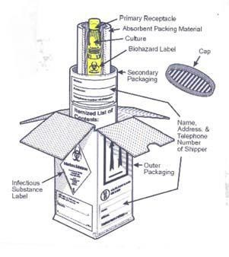
Primary receptacle (tube, vial, bottle)
- The primary receptacle holds the specimen.
- The primary receptacle must be securely sealed and leak proof (screw top tubes must have a piece of waterproof tape around the top to prevent the top from coming loose in transit).
- The primary receptacle must be surrounded by absorbent material capable of taking up the entire liquid contents.
- The primary receptacle must be packed in the secondary receptacle in such a way that it will not break.

Secondary packaging
- This is where the primary receptacle and the absorbent and cushioning material are placed.
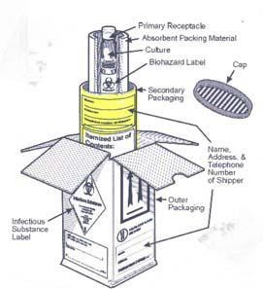
- The secondary packaging must be leak proof and securely sealed.
- The secondary packaging must be placed in the outer packaging so that it does not move.
- The biohazard marking should be on the secondary receptacle and may be on the primary receptacle.
- Itemized list of contents:
  - An itemized list of contents is required. DO NOT place documents inside the secondary container.
  - The itemized list is placed OUTSIDE the secondary container. The laboratory test requisition form may serve this purpose. The form should also be placed OUTSIDE the secondary container.

Outer packaging
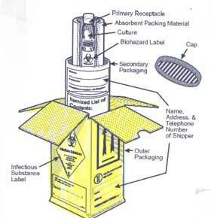
- The outer container is the receptacle into which the secondary packaging with cushioning materials are placed.
- The outer packaging must be rigid.
- The outer packaging bears the addressing information along with all required markings and labels. The full name and address of the shipper and the consignee must be on the outside packaging. The outside packaging must also have the name and telephone number of a person who is knowledgeable about the contents of the shipment. This is important emergency information in the event an exposure occurs during shipping.
For liquids, absorbent material in sufficient quantity to absorb the entire contents should be placed between the primary receptacle(s) and the secondary packaging so that, during transport, any release or leak of a liquid substance will not reach the outer packaging and will not compromise the integrity of the cushioning material. When multiple fragile primary receptacles are placed in a single secondary packaging, they should be either individually wrapped or separated to prevent contact between them.

Send-away (overseas) testing
Tests marked SEND-AWAY in the department test tables above are not processed at VNH - they are referred out, and results take days to weeks rather than hours. Discuss timing with the relevant department before sending. If a test is needed that isn't listed anywhere in this handbook, contact the relevant department directly; they can advise whether it can be referred out.
Specimens from Operating Theatre, wards, or Reception that need further referral should be sent to the Laboratory Department Reception Unit, which coordinates onward shipment.

Laboratory results and reports
All hard-copy results are available from the Laboratory Department Reception Unit's respective ward pigeonholes. Routine results are dispatched to ward pigeonholes twice daily (around 12:00 and before 16:00).
- Unexpectedly or markedly abnormal results are routinely telephoned to the concerned clinician.
- Hard copies of abnormal results are flagged to attract the attention of the Nurse-in-Charge and delivered to the ward promptly once verified by the duty scientist.
- Ward, OPD, and SOPD staff must sign the Result Register Log Book when collecting reports. Patients and family members are discouraged from collecting results directly, to protect confidentiality.
- All reports require two laboratory officers' signatures (performed-by and verified-by) before they may leave the laboratory; reports without verification signatures must not be removed.
- Corrections to a report must be made with a single straight line through the incorrect result, the corrected result written alongside, and signed with date and time — scribbled-over or overwritten results must not be accepted as evidence for patient management. See example below;
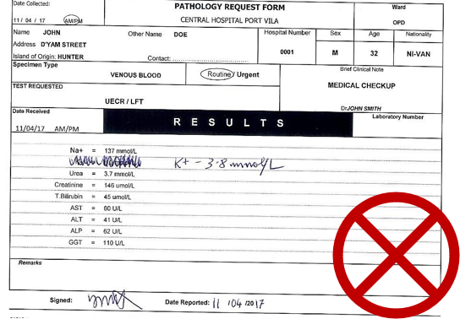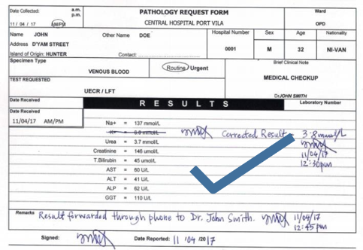

Laboratory Consumables
VNH departments can order laboratory consumables (specimen collection materials etc) using the approved Laboratory Consumable Order Form (Annexure 6). Orders are placed by unit size, on Thursdays only, and must be authorized by a supervisor's signature.

Annexure 1 — Transfusion Adverse Reactions
Transfusion reactions can be classified in simple categories in order to help you to recognize them, understand their underlying causes and when they may occur, and know how to prevent, manage and record them. Acute complications of transfusion Acute transfusion reactions occur during or shortly after (within 24 hours) the transfusion. They can be broadly classified in the following three categories according to their severity and the appropriate clinical response.

Acute reactions (during or within 24 hours of transfusion)

Category 1: Mild
- Mild hypersensitivity -- allergic, urticarial reactions.

Category 2: Moderately severe
- Moderate-severe hypersensitivity (severe urticarial reactions).
- Febrile non-haemolytic reactions -- antibodies to white cells/platelets, antibodies to proteins (including IgA), possible early bacterial contamination, pyrogens.

Category 3: Life-threatening
- Acute intravascular haemolysis.
- Bacterial contamination and septic shock.
- Fluid overload.
- Anaphylactic reactions.
- Transfusion-associated lung injury.

Delayed complications
Transfusion-transmitted infections: HIV-1/2, HTLV-I/II, hepatitis B and C, syphilis, Chagas disease, malaria, cytomegalovirus, and other rare infections (e.g. human parvovirus B19, hepatitis A).
Other delayed complications (days, months, or years later): delayed haemolytic reaction, post-transfusion purpura, graft-versus-host disease, and iron overload in repeatedly transfused patients.

Annexure 2 – Laboratory Request Form
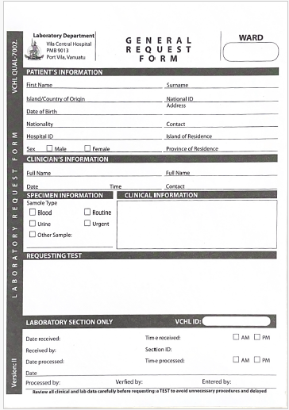

Annexure 3 – Crossmatch request form
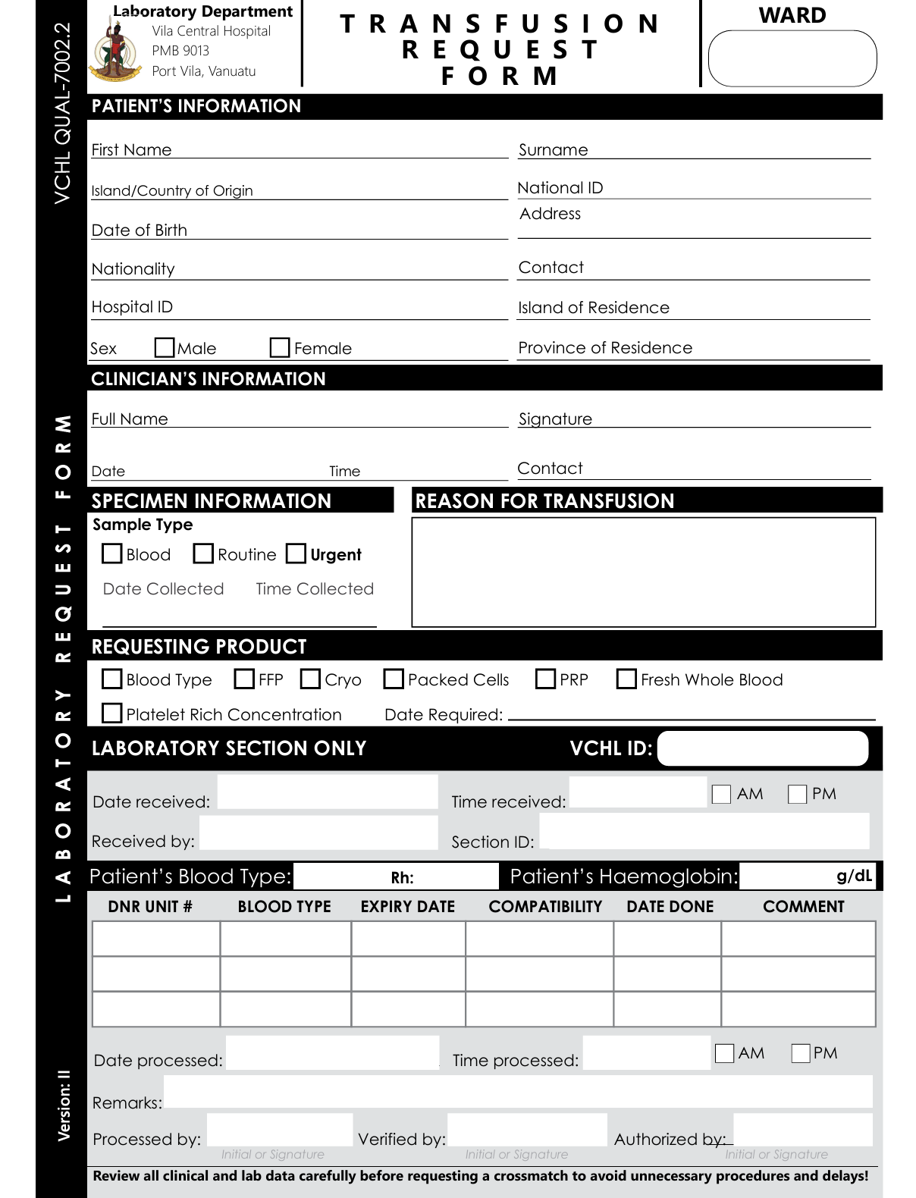

Annexure 4 – TB Request Form
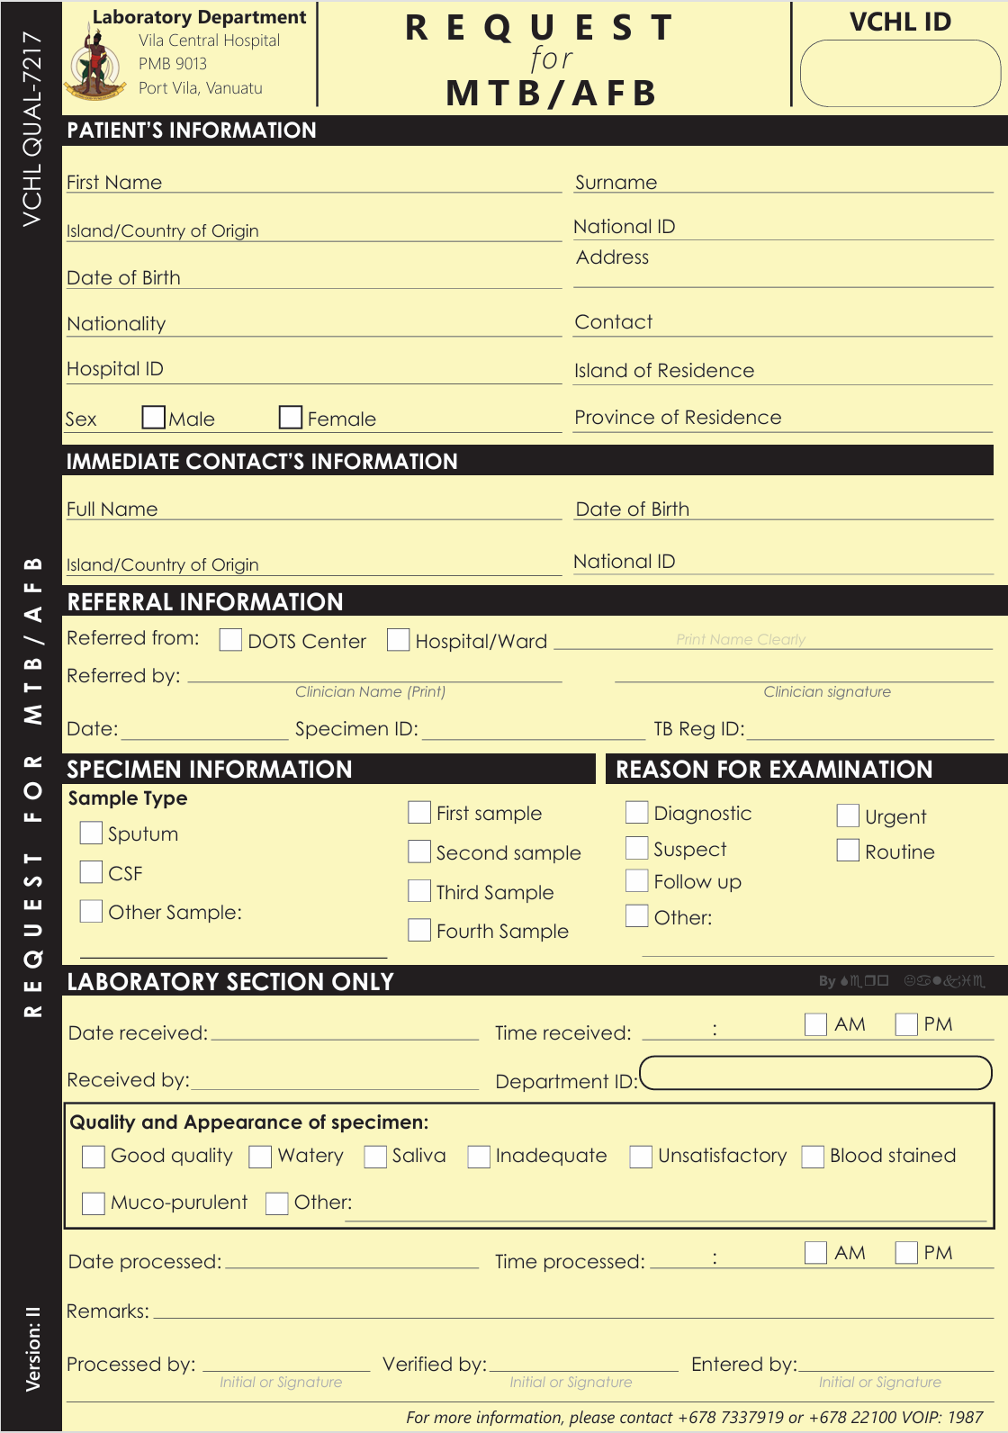

Annexure 5 – Laboratory Surveillance Form
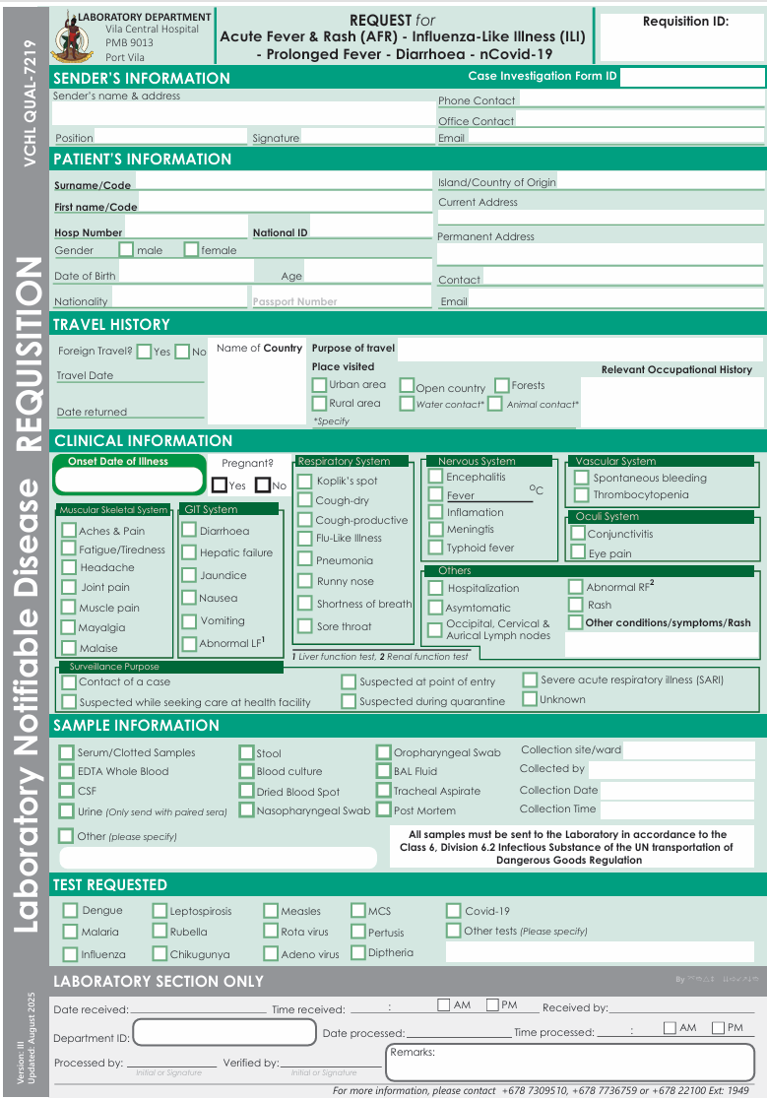

Annexure 6 – Laboratory consumable order form
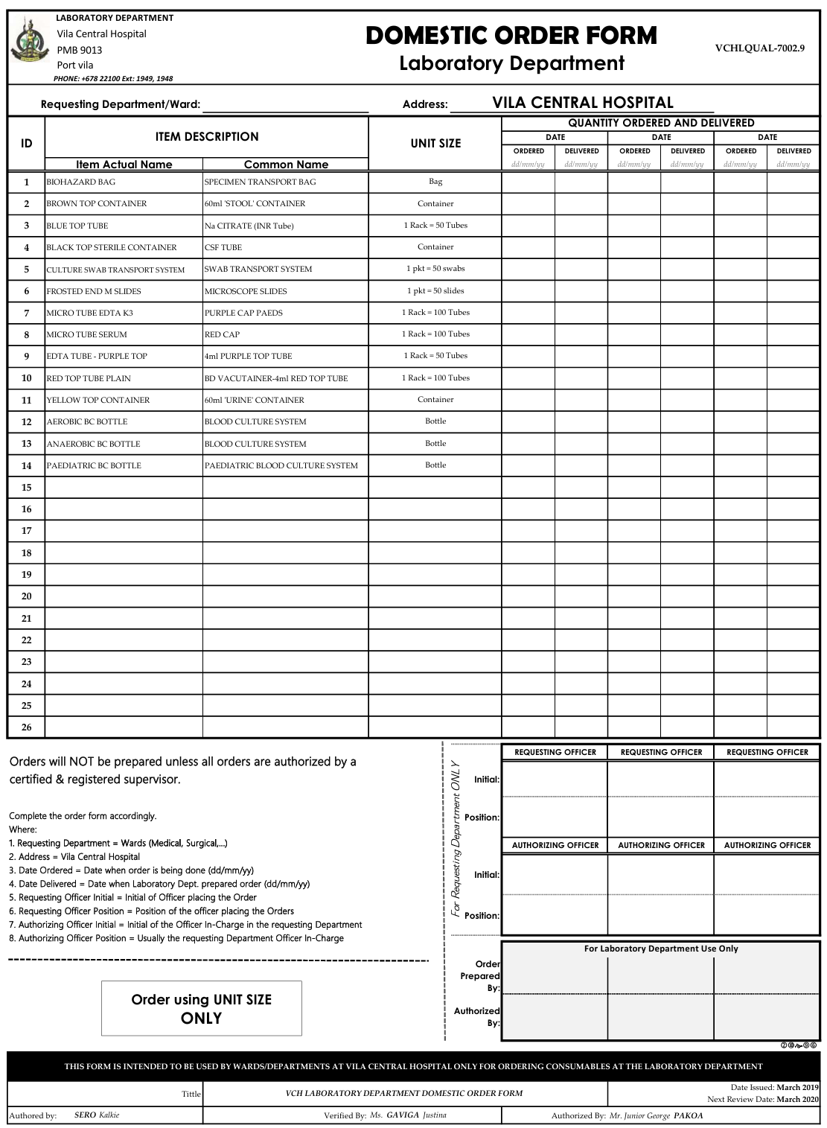

Annexure 7 – Laboratory complaint & compliment form
